**FULL STACK DEVELOPMENT**

Online Hotel Booking System

*Summer Internship Report Submitted in partial fulfilment*

*of the requirement for under graduate degree of*

**BACHELOR OF TECHNOLOGY**

**IN**

**COMPUTER SCIENCE AND ENGINEERING**

By

**S. Harshitha**

**221710301047**

[https://github.com/harshitha047](https://github.com/harshitha047/full-stack)

*Under the Guidance of*

Assistant Professor



Department Of Computer Science and Engineering

GITAM School of Technology

GITAM (Deemed to be University)

Hyderabad-502329

July 2020

**DEPARTMENT OF COMPUTER SCIENCE AND ENGINEERING**

**SCHOOL OF TECHNOLOGY**

**GITAM**

**(Deemed-to-be-University u/s 3 of UGC Act 1956)**

**HYDERABAD CAMPUS**



**DECLARATION**

I submit this industrial training work entitled **“Online Hotel Booking System**” to GITAM (Deemed to Be University), Hyderabad in partial fulfilment of the requirements for the award of the degree of “**Bachelor of Technology**” in “**Computer Science and Engineering**”. I declare that it was carried out independently by me under the guidance of **()**, Asst. Professor, GITAM (Deemed to Be University), Hyderabad, India.

The results embodied in this report have not been submitted to any other University or Institute for the award of any degree or diploma.

Place: Hyderabad **Name and Signature of Candidate**

Date:S . Harshitha

221710301047

CSE

**DEPARTMENT OF COMPUTER SCIENCE AND ENGINEERING**

**GITAM SCHOOL OF TECHNOLOGY**

**GITAM**

**(Deemed-to-be-University u/s 3 of UGC Act 1956)**

**HYDERABAD CAMPUS**



**CERTIFICATE**

This is to certify that the Industrial Training Report entitled – “**Online Hotel** **Booking System** " is being submitted by **S.HARSHITHA(221710301047)**, submitted in partial fulfillment of the requirements for the award of degree of **Bachelor of Technology** in **Computer Science and Engineering**.

**Guided by Head of the Department**

**Dr. Phani Kumar**

**Professor & HOD**

**ACKNOWLEDGEMENT**

My project would not have been successful without the help of several people, I would like to thank the personalities who were part of my project in numerous ways, those who gave me outstanding support from the birth of the project.

I am extremely thankful to our honorable Pro-Vice-Chancellor, **Prof. N. Siva Prasad** for providing necessary infrastructure and resources for the accomplishment of my project.

I am highly indebted to **Prof. N. Seetharamaiah**, Principal, School of Technology, for his support during the tenure of the project.

I am very much obliged to our beloved **Prof. S. Phani Kumar**, Head of the Department of Computer Science & Engineering for providing the opportunity to undertake this project and encouragement in the completion of this project.

I hereby wish to express my deep sense of gratitude to **Mr. Anil Kumar**, for the esteemed guidance, moral support and invaluable advice provided by him for the success of the project.

I am also thankful to all the staff and mentors of the Dhyanahitha School of Professional Studies who have cooperated in making my project a success. I would like to thank my parents and friends who extended their help, encouragement and moral support either directly or indirectly in our project work.

Sincerely,

S. Harshitha (221710301047)

**ABSTRACT**

The project “**Online Hotel Booking System**” is a system based on accessing

the internet to book for rooms in a hotel. The purpose of this study is to develop and

implement an online hotel reservation system for hotels that will replace the manual

method of booking for hotel rooms. The previous system for booking rooms were

faced with so many problems like, delay in processing the customer booking or

paying for rooms that is below or beyond his standard, causes difficulty for

emergency booking. The internet and information unprecedented important.

Furthermore, it Changes The way that people book rooms, which makes rooms-

booking diversified, convenient and individualized. Therefore, the subject of system

development of a WEB-based hotel booking system is proposed. This is just an

overview of bookings in hotels. This has been achieved by by dividing the project into

various modules. Customer is provided with different services like check-ins,check-outs,

galleries, contacting the hotel management, bookings ,paying bills etc. The use of

online view of room rates and uploading of available rooms and facilities was used for

the new system so that the customer can view and make his choice before arrival, and

also in the case of emergency travelling. This new system assisted the hotel owners in

managing their hotels, because they can also regulate the receptionist moves and

avoid fraudulent activities. It also increased the efficiency of the hotel managers and

also their profit margin, once they have better and good facilities. By adding many

more modules this type of project can have scope in various hotels.

**Table of Contents**

1. Introduction…………………………………...…………………………………….8

Information about the Full Stack Development 9

1.1. Web Development 9

1.1.1 Web Site 9

1.1.2 Web Page 10

1.2 Steps to Create a Web Site 11

1.2.1 UI Development 12

1.2.2 Scripting 17

1.2.3 Data Base 19

1.2.4 SQL 20

1.2.5 Queries 20

1.3 Scripting Languages……………………………………………………...21-25

2. Software Requirements 26

2.1 Hardware Requirements 26

2.2 Software Requirements 26

3. Project Name 27

3.1 Project Name: 27

3.2 Technologies Used: 27

3.3 Technical Details: 27

4. Modules 28

4.1 Home Page………………………………………………………………28-30

4.2 Rooms Page……………………………………………………………..30-32

4.3 Gallery Page ……………………………………………………………32-33

4.4 Login & signup Page……………………………………………………33-34

4.5 Contact us Page……………………………………………………………..34

4.6 About Page………………………………………………………………….35

4.7 Bookings Page…………………………………………………………..35-36

5. Outputs 37

5.1 Wireframes……………………………………………………..…..…...37-41

5.2 Validations, API MYSQL CODES……………………………………..42-51

5.3 Outputs…………………………………………………………….……51-55

6. Workflow 56-57

7. Maintenance 58

8. Future Scope and Future Enhancement 59

9. Conclusion 60

**List of Figures**

Figure 1.2.1(1)-Step to create a website

Figure 1.2.2(1)-Login form without CSS

Figure 1.2.2(2)-Login form without CSS

Figure 1.3.1-Uses of nodejs

Figure 1.3.3-Javascript

Figure 4.1-HOME

Figure 4.2-ROOMS

Figure 4.3-GALLERY

Figure 4.4-BOOKING

Figure 4.5-LOGIN

Figure 4.6-SIGN UP

Figure 5.1.1-Wireframes HOME

Figure 5.1.2-Wireframes ROOMS

Figure 5.1.3-Wireframes GALLERY

Figure 5.1.4-Wireframes BOOKINGS

Figure 5.1.5-Wireframes LOGIN SIGN UP

Figure 5.2.1- API –

login code

Registration code

db.config.js

Figure 5.2.2-register.controller.js

Figure 5.2.3-db.js

Figure 5.2.4-register.model.js

Figure 5.2.5-register.route.js

Figure 5.2.6-server.js

Figure 5.3.1-Outputs

Figure 5.3.2-Outputs

Figure 5.3.3-Outputs

Figure 5.3.4-Outputs

Figure 5.3.5-Outputs

Figure 5.5-Class Diagram

Figure 5.6-Use Case Diagram

**CHAPTER – 1**

### **INTRODUCTION**

The industry definition of a Full Stack Developer is an engineer who can work on different levels of an application stack. The term stack refers to the combination of components and tools that make up the application. The components could be in the front-end or the back-end of the system. The main objective of full stack engineer is to keep every part of the system running smoothly. A Full Stack Developer can perform tasks ranging from resizing an image or text in a webpage to patching the kernel.

**Full stack development:** It refers to the development of both front end(client side) and back end(server side) portions of web application.

**Full stack web Developers:** Full stack web developers have the ability to design complete web application and websites. They work on the frontend, backend, database and debugging of web application or websites.

**FRONT-END**

Front-end web development, also known as client-side development is the practice of producing HTML, CSS and JavaScript for a website or Web Application so that a user can see and interact with them directly. The challenge associated with front end development is that the tools and techniques used to create the front end of a website change constantly and so the developer needs to constantly be aware of how the field is developing.

The objective of designing a site is to ensure that when the users open up the site they see the information in a format that is easy to read and relevant. This is further complicated by the fact that users now use a large variety of devices with varying screen sizes and resolutions thus forcing the designer to take into consideration these aspects when designing the site. They need to ensure that their site comes up correctly in different browsers (cross-browser), different operating systems (cross-platform) and different devices (cross-device), which requires careful planning on the side of the developer.

Front end development manages everything that users visually see first in their browser or application. Front end developers are responsible for the look and feel of a site. It is the visible part of website or web application which is responsible for user experience. The user directly interacts with the front end portion of the web application or website.

**BACK-END**

Back end development refers to the server side of an application and everything that communicates between the database and the browser. It is responsible for managing the database through queries and APIs by client-side commands.

Back end development refers to the server side of development where you are primarily focused on how the site works. Making updates and changes in addition to monitoring functionality of the site will be your primary responsibility. This type of web development usually consists of three parts: a server, an application, and a database. Code written by back end developers is what communicates the database information to the browser. Anything you can’t see easily with the eye such as databases and servers is the work of a back end developer. Back end developer positions are often called programmers or web developers.

**INFORMATION ABOUT THE FULL STACK DEVELOPMENT**

* 1. **WEB DEVELOPMENT:**

Web development is a broad term for the work involved in developing a [web site for](https://en.wikipedia.org/wiki/Web_site) the [Internet (](https://en.wikipedia.org/wiki/Internet)[World Wide Web)](https://en.wikipedia.org/wiki/World_Wide_Web) or an [intranet (](https://en.wikipedia.org/wiki/Intranet)a private network). Web development can range from developing the simplest static single page of [plain text to](https://en.wikipedia.org/wiki/Plain_text) the most complex web-based [internet applications,](https://en.wikipedia.org/wiki/Internet_application) businesses, and [social network services.](https://en.wikipedia.org/wiki/Social_network_service) A more comprehensive list of tasks to which web development commonly refers, may include [web engineering,](https://en.wikipedia.org/wiki/Web_engineering) [web design,](https://en.wikipedia.org/wiki/Web_design) [web content development,](https://en.wikipedia.org/wiki/Web_content_development) client liaison, [client-side/s](https://en.wikipedia.org/wiki/Client-side_scripting)ide scripting, [web server a](https://en.wikipedia.org/wiki/Web_server)nd [network security c](https://en.wikipedia.org/wiki/Network_security)onfiguration, and [e-commerce d](https://en.wikipedia.org/wiki/E-commerce)evelopment. Among web professionals, "web development" usually refers to the main non-design aspects of building web sites: writin[g markup](https://en.wikipedia.org/wiki/Markup_language) and [coding.](https://en.wikipedia.org/wiki/Computer_programming) Most recently Web development has come to mean the creation of [content management systems or](https://en.wikipedia.org/wiki/Content_management_system) CMS. These CMS can be made from scratch, proprietary or open source. In broad terms the CMS acts as middleware between the database and the user through the browser. A principle benefit of a CMS is that it allows non-technical people to make changes to their web site without having technical knowledge.

For larger organizations and businesses, web development teams can consist of hundreds of people ([web developers)](https://en.wikipedia.org/wiki/Web_developer) and follow standard methods like [Agile methodologies](https://en.wikipedia.org/wiki/Agile_software_development) while developing websites. Smaller organizations may only require a single permanent or contracting developer, or secondary assignment to related job positions such as a [graphic designer o](https://en.wikipedia.org/wiki/Graphic_designer)r [information systems t](https://en.wikipedia.org/wiki/Information_systems)echnician. Web development may be a collaborative effort between departments rather than the domain of a designated department. There are three kind of web developer specialization: front-end developer, back-end developer, and full-stack developer.

* + 1. **Web Site:**

A website is a collection of related [web pages, in](https://en.wikipedia.org/wiki/Web_page)cluding [multimedia c](https://en.wikipedia.org/wiki/Multimedia)ontent, typically identified with a common [domain name, a](https://en.wikipedia.org/wiki/Domain_name)nd published on at least one [web server.](https://en.wikipedia.org/wiki/Web_server) A website may be accessible via a public [Internet Protocol (](https://en.wikipedia.org/wiki/Internet_Protocol)IP) network, such a[s the Internet, or](https://en.wikipedia.org/wiki/Internet) a private [local area network (](https://en.wikipedia.org/wiki/Local_area_network)LAN), by referencing a [uniform resource locator (](https://en.wikipedia.org/wiki/URL)URL) that identifies the site.

Websites have many functions and can be used in various fashions; a website can be a [personal website, a](https://en.wikipedia.org/wiki/Personal_website) commercial website for a company, a [government website or](https://en.wikipedia.org/wiki/E-Government) a [non-profit organization w](https://en.wikipedia.org/wiki/Nonprofit_organization)ebsite. Websites are typically dedicated to a particular topic or purpose, ranging from entertainment and [social networking to](https://en.wikipedia.org/wiki/Social_networking) providing news and education. All publicly accessible websites collectively constitute the [World Wide Web,](https://en.wikipedia.org/wiki/World_Wide_Web) while private websites, such as a company's website for its employees, and are typically a part of an [intranet.](https://en.wikipedia.org/wiki/Intranet) A web site consists of web pages which are interconnected to each other and contain various data and functionalities.

Web pages, which are the [building blocks of](https://en.wikipedia.org/wiki/Building_block) websites, are [documents,](https://en.wikipedia.org/wiki/Document) typically composed in [plain text in](https://en.wikipedia.org/wiki/Plain_text)terspersed with formatting instructions of Hypertext Markup Language [(HTML,](https://en.wikipedia.org/wiki/HTML) [XHTML).](https://en.wikipedia.org/wiki/XHTML) They may incorporate elements from other websites with suita[ble markup anchors.](https://en.wikipedia.org/wiki/HTML_anchor) Web pages are accessed and transported with the [Hypertext Transfer Protocol (](https://en.wikipedia.org/wiki/Hypertext_Transfer_Protocol)HTTP), which may optionally employ encryption ([HTTP Secure, H](https://en.wikipedia.org/wiki/HTTP_Secure)TTPS) to provide security and privacy for the user. The user's application, often a [web browser,](https://en.wikipedia.org/wiki/Web_browser) renders the page content according to its HTML markup instructions onto a display terminal.

[Hyper linking b](https://en.wikipedia.org/wiki/Hyperlink)etween web pages conveys to the reader the [site structure a](https://en.wikipedia.org/wiki/Site_map)nd guides the navigation of the site, which often starts with a [home page c](https://en.wikipedia.org/wiki/Home_page)ontaining a directory of the site [web content. S](https://en.wikipedia.org/wiki/Web_content)ome websites require user registration or [subscription to](https://en.wikipedia.org/wiki/Subscription) access content. Examples of [subscription websites include](https://en.wikipedia.org/wiki/Paywall) many business sites, news websites, [academic journal w](https://en.wikipedia.org/wiki/Academic_journal)ebsites, gaming websites, file-sharing websites, [message boards,](https://en.wikipedia.org/wiki/Internet_forum) web-based [email,](https://en.wikipedia.org/wiki/Email) [social networking w](https://en.wikipedia.org/wiki/Social_networking)ebsites, websites providing real-time [stock market d](https://en.wikipedia.org/wiki/Stock_market)ata, as well as sites providing various other services.

* + 1. **Web Page:**

A web page, or webpage, is a document that is suitable for the [World Wide Web a](https://en.wikipedia.org/wiki/World_Wide_Web)nd [web browsers. A](https://en.wikipedia.org/wiki/Web_browser) web browser displays a web page on a [monitor or](https://en.wikipedia.org/wiki/Computer_display) [mobile device. The](https://en.wikipedia.org/wiki/Mobile_device) web page is what displays, but the term also refers to a [computer file,](https://en.wikipedia.org/wiki/Computer_file) usually written in [HTML o](https://en.wikipedia.org/wiki/HTML)r comparable [markup language. W](https://en.wikipedia.org/wiki/Markup_language)eb browsers coordinate the various [web resource e](https://en.wikipedia.org/wiki/Web_resource)lements for the written web page, such as [style sheets](https://en.wikipedia.org/wiki/Cascading_Style_Sheets)[, scripts, a](https://en.wikipedia.org/wiki/Client-side_scripting)[nd images,](https://en.wikipedia.org/wiki/Image) to present the web page.

Typical web pages provide [hypertext that](https://en.wikipedia.org/wiki/Hypertext) includes a [navigation bar o](https://en.wikipedia.org/wiki/Navigation_bar)r a [sidebar menu to other web page](https://en.wikipedia.org/wiki/Sidebar_%28computing%29)[s via hyperlinks,](https://en.wikipedia.org/wiki/Hyperlink) often referred to as links.

On a network, a web browser can retrieve a web page from a remote [web server.](https://en.wikipedia.org/wiki/Web_server) On a higher level, the web server may restrict access to only a private network such as a corporate [intranet or](https://en.wikipedia.org/wiki/Intranet) it provides access to the World Wide Web. On a lower level, the web browser uses [the Hypertext Transfer Protocol](https://en.wikipedia.org/wiki/Hypertext_Transfer_Protocol) (HTTP) to make such requests.

[A static web page](https://en.wikipedia.org/wiki/Static_web_page) is delivered exactly as stored, as [web content in](https://en.wikipedia.org/wiki/Web_content) the web server's [file system, while](https://en.wikipedia.org/wiki/File_system) a [dynamic web page is](https://en.wikipedia.org/wiki/Dynamic_web_page) generated by a [web application that](https://en.wikipedia.org/wiki/Web_application) is driven by [server- side software or](https://en.wikipedia.org/wiki/Server-side_scripting) client-side scripting. Dynamic website pages help the browser (the [client)](https://en.wikipedia.org/wiki/Client_%28computing%29) to enhance the web page through user input to the server.

* 1. **STEPS TO CREATE A WEBSITE:**

Creating a web site requires multiple steps which includes the following:

• Creating a UI (User interface) 

• Scripting (Both at server end and client end) 

• creating a backend or the database 

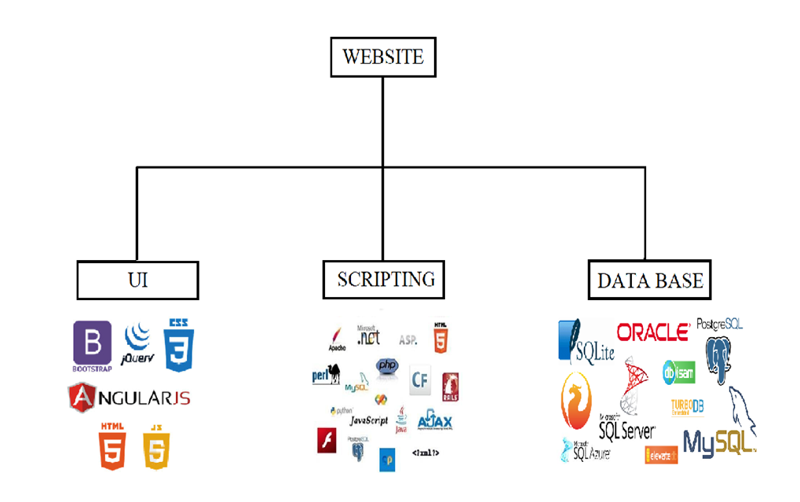

**Fig 1.2.1**

* + 1. **UI Development:**

Technologies that are mostly used to develop a User Interface are:

* HTML
* CSS
* Bootstrap

**HTML:**

Hypertext Markup Language (HTML) is the standard [markup language for](https://en.wikipedia.org/wiki/Markup_language) creating [web pages a](https://en.wikipedia.org/wiki/Web_page)nd [web applications.](https://en.wikipedia.org/wiki/Web_application) With [Cascading Style Sheets (C](https://en.wikipedia.org/wiki/Cascading_Style_Sheets)SS) and [JavaScript it](https://en.wikipedia.org/wiki/JavaScript) forms a triad of cornerstone technologies for the [World Wide Web.](https://en.wikipedia.org/wiki/World_Wide_Web) [Web browsers r](https://en.wikipedia.org/wiki/Web_browser)eceive HTML documents from a [webserver or](https://en.wikipedia.org/wiki/Webserver) from local storage and render them into multimedia web pages. HTML describes the structure of a web page [semantically a](https://en.wikipedia.org/wiki/Semantic)nd originally included cues for the appearance of the document.

[HTML elements a](https://en.wikipedia.org/wiki/HTML_element)re the building blocks of HTML pages. With HTML constructs, [images a](https://en.wikipedia.org/wiki/Img_%28HTML_element%29)nd other objects, such as [interactive forms, m](https://en.wikipedia.org/wiki/Fieldset)ay be embedded into the rendered page. It provides a means to create [structured documents b](https://en.wikipedia.org/wiki/Structured_document)y denoting structural [semantics for](https://en.wikipedia.org/wiki/Semantics) text such as headings, paragraphs, lists, [links,](https://en.wikipedia.org/wiki/Hyperlink) quotes and other items. HTML elements are delineated by tags, written using [angle brackets.](https://en.wikipedia.org/wiki/Bracket#Angle_brackets) Tags such as <img /> and <input /> introduce content into the page directly. Others such as <p>...</p> surround and provide information about document text and may include other tags as sub-elements. Browsers do not display the HTML tags, but use them to interpret the content of the page.

HTML can embed programs written in a [scripting language su](https://en.wikipedia.org/wiki/Scripting_language)ch as [JavaScript whi](https://en.wikipedia.org/wiki/JavaScript)ch affect the behavior and content of web pages. Inclusion of CSS defines the look and layout of content. The [World Wide Web Consortium (](https://en.wikipedia.org/wiki/World_Wide_Web_Consortium)W3C), maintainer of both the HTML and the CSS standards, has encouraged the use of CSS over explicit presentational HTML since 1997.

HTML markup consists of several key components, including those called tags (and their attributes), character-based data types, character references and entity references. HTML tags most commonly come in pairs like <h1> and </h1>, although some represent empty elements and so are unpaired, for example <img>. The first tag in such a pair is the start tag, and the second is the end tag (they are also called opening tags and closing tags).

Another important component is the HTM[L document type declaration,](https://en.wikipedia.org/wiki/Document_type_declaration) which triggers [standards](https://en.wikipedia.org/wiki/Standards_mode) mode rendering.

The following is an example of the classic [Hello world program, a](https://en.wikipedia.org/wiki/Hello_world_program) common test employed for comparing [programming languages,](https://en.wikipedia.org/wiki/Programming_language) [scripting languages a](https://en.wikipedia.org/wiki/Scripting_language)nd [markup languages.](https://en.wikipedia.org/wiki/Markup_language) This example is made using 9 [lines of code:](https://en.wikipedia.org/wiki/Lines_of_code)

**General syntax of HTML:**

<!DOCTYPE html>

<html>

<head>

<title>TITLE</title>

</head>

<body>

<p>Hello World</p>

</body>

</html>

(The text between <html> and </html> describes the web page, and the text between <body> and </body> is the visible page content. The markup text "<title>this is a title</title>" defines the browser page title.)

The Document Type Declaration <! DOCTYPE html> is for HTML5. If a declaration is not included, various browsers will reve[rt to "quirks](https://en.wikipedia.org/wiki/Quirks_mode) mode" for rendering.

**CSS:**

Cascading Style Sheets (CSS) is a [style sheet language us](https://en.wikipedia.org/wiki/Style_sheet_language)ed for describing the [presentation of](https://en.wikipedia.org/wiki/Presentation_semantics) a document written in a [markup language. Althou](https://en.wikipedia.org/wiki/Markup_language)gh most often used to set the visual style of [web pages a](https://en.wikipedia.org/wiki/Web_page)nd user interfaces written in [HTML a](https://en.wikipedia.org/wiki/HTML)nd [XHTML,](https://en.wikipedia.org/wiki/XHTML) the language can be applied to any [XML d](https://en.wikipedia.org/wiki/XML)ocument, including [plain XML,](https://en.wikipedia.org/wiki/Plain_Old_XML) [SVG a](https://en.wikipedia.org/wiki/Scalable_Vector_Graphics)nd [XUL,](https://en.wikipedia.org/wiki/XUL) and is applicable to rendering in [speech, or](https://en.wikipedia.org/wiki/Speech_synthesis) on other media. Along with HTML and [JavaScript,](https://en.wikipedia.org/wiki/JavaScript) CSS is a cornerstone technology used by most websites to create visually engaging WebPages, user interfaces for [web applications,](https://en.wikipedia.org/wiki/Web_applications) and user interfaces for many mobile applications.

CSS is designed primarily to enable the separation of presentation and content, including aspects such as the [layout,](https://en.wikipedia.org/wiki/Page_layout) [colors,](https://en.wikipedia.org/wiki/Color) and fonts. This separation can improve content [accessibility, provi](https://en.wikipedia.org/wiki/Accessibility)de more flexibility and control in the specification of presentation characteristics, enable multiple HTML pages to share formatting by specifying the relevant CSS in a separate .css file, and reduce complexity and repetition in the structural content.

Separation of formatting and content makes it possible to present the same markup page in different styles for different rendering methods, such as on-screen, in print, by voice (via speech-based browser or [screen reader)](https://en.wikipedia.org/wiki/Screen_reader), and on [Braille-based ta](https://en.wikipedia.org/wiki/Braille_display)ctile devices.

The CSS specification describes a priority scheme to determine which style rules apply if more than one rule matches against a particular element. In this so-called cascade, priorities (or weights) are calculated and assigned to rules, so that the results are predictable.

The CSS specifications are maintained by the [World Wide Web Consortium (W3C).](https://en.wikipedia.org/wiki/World_Wide_Web_Consortium) Internet media type ([MIME type)](https://en.wikipedia.org/wiki/MIME_media_type) text/css is registered for use with CSS [by RFC 2318 (](https://tools.ietf.org/html/rfc2318)March 1998). The W3C operates a free [CSS validation service for](https://en.wikipedia.org/wiki/W3C_Markup_Validation_Service#CSS_validation) CSS documents.

**Types of CSS:**

• Inline CSS:

In this CSS is applied in between the tags

E.g.: <tag style=”styling”>Hello World</tag>

• Internal CSS:

In this, the css code is defined inside the style tag in the head section of the HTML page.

Syntax:

<html>

<head>

<style>

<! -- CSS STYLING -- >

</style>

</head>

</html>

* External CSS: 

In this the CSS code is written on another page and is linked to the HTML page. It is advantageous to use this type of styling as we can use the same file to style various HTML pages.

External CSS uses the extension .css and is applied using the following syntax:

<html>

<head>

<link relation=”style sheet” type=”css” href=”url to the page”>

</head>

</html>

All the CSS style types are important but can be used in different situations.

• Inline CSS is used when only small changes are to be done to the HTML tag and the changes are to be reflected only to that specific tag

• Internal CSS is used when the individual HTML pages have to be designed differently. This also slows the page load system if the internal styling is long. 

• External CSS files are maintained to design multiple pages and use common styles over various pages. It is useful as it helps in managing the resources in an easy manner. 

Both HTML and CSS are used to create a UI but CSS behaves like a makeup on the face of an actress which makes her look even more beautiful than she is in reality.

And here is the difference:

**Before using CSS in HTML page**

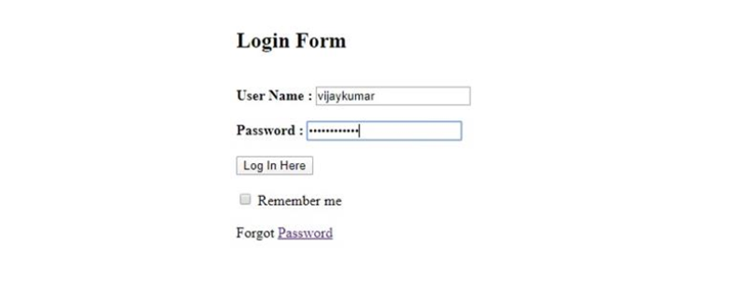

**Fig 1.2.2(1)**

**After using CSS in HTML page:**



**Fig 1.2.2(2)**

**BOOTSTRAP:**

Bootstrap is a [free and open-source f](https://en.wikipedia.org/wiki/Free_and_open-source_software)ront-end [web framework for](https://en.wikipedia.org/wiki/Web_framework) designing [websites](https://en.wikipedia.org/wiki/Website) and [web applications. I](https://en.wikipedia.org/wiki/Web_application)t contains [HTML-](https://en.wikipedia.org/wiki/HTML) and [CSS-](https://en.wikipedia.org/wiki/CSS)based design templates for [typography,](https://en.wikipedia.org/wiki/Typography) forms, buttons, navigation and other interface components, as well as optional [JavaScript](https://en.wikipedia.org/wiki/JavaScript) extensions. Unlike many web frameworks, it concerns itself with [front-end development on](https://en.wikipedia.org/wiki/Front-end_web_development)ly.

Bootstrap is the second most-starred project on [GitHub,](https://en.wikipedia.org/wiki/GitHub) with more than 107,000 stars and 48,000 forks.

Bootstrap, originally named Twitter Blueprint, was developed by Mark Otto and Jacob Thornton at [Twitter a](https://en.wikipedia.org/wiki/Twitter)s a framework to encourage consistency across internal tools. Before Bootstrap, various libraries were used for interface development, which led to inconsistencies and a high maintenance burden. According to [twitter d](https://en.wikipedia.org/wiki/Twitter)eveloper Mark Otto:

“A super small group of developers and I got together to design and build a new internal tool and saw an opportunity to do something more. Through that process, we saw ourselves build something much more substantial than another internal tool. Months later, we ended up with an early version of Bootstrap as a way to document and share common design patterns and assets within the company.”

After a few months of development by a small group, many developers at Twitter began to contribute to the project as a part of Hack Week, a [hackathon-](https://en.wikipedia.org/wiki/Hackathon)style week for the Twitter development team. It was renamed from Twitter Blueprint to Bootstrap, and released as an open source project on August 19, 2011. It has continued to be maintained by Mark Otto, Jacob Thornton, and a small group of core developers, as well as a large community of contributors.

On January 31, 2012, Bootstrap 2 was released, which added a twelve-column [responsive g](https://en.wikipedia.org/wiki/Responsive_web_design)rid layout system, inbuilt support for Glyph icons, several new components, as well as changes to many of the existing components.

On August 19, 2013, Bootstrap 3 was released, which redesigned components to use [flat design, a](https://en.wikipedia.org/wiki/Flat_design)[nd a mobile first a](https://en.wikipedia.org/wiki/Responsive_web_design#Mobile_first.2C_unobtrusive_JavaScript.2C_and_progressive_enhancement)pproach.

On October 29, 2014, Mark Otto announced that Bootstrap 4 was in development. The first alpha version of Bootstrap 4 was released on August 19, 2015.

Bootstrap 3 supports the latest versions of the [Google](https://en.wikipedia.org/wiki/Google_Chrome) [Chrome, Firefox](https://en.wikipedia.org/wiki/Firefox)[, Internet Explorer,](https://en.wikipedia.org/wiki/Internet_Explorer) [Opera, a](https://en.wikipedia.org/wiki/Opera_%28web_browser%29)nd [Safari (e](https://en.wikipedia.org/wiki/Safari_%28web_browser%29)xcept on Windows). It additionally supports back to [IE8 a](https://en.wikipedia.org/wiki/Internet_Explorer_8)nd the latest [Firefox E](https://en.wikipedia.org/wiki/Firefox)xtended Support Release (ESR).

Since 2.0, Bootstrap supports [responsive web design.](https://en.wikipedia.org/wiki/Responsive_Web_Design) This means the layout of web pages adjusts dynamically, taking into account the characteristics of the device used (desktop, tablet, mobile phone).

Starting with version 3.0, Bootstrap adopted a [mobile-first design phi](https://en.wikipedia.org/wiki/Mobile-first_design)losophy, emphasizing responsive design by default. The version 4.0 alpha release added [Sass a](https://en.wikipedia.org/wiki/Sass_%28stylesheet_language%29)[nd flex box support.](https://en.wikipedia.org/wiki/CSS_Flex_Box_Layout)

* + 1. **Scripting:**

There are two scripting methodologies.

1. Server side scripting: This scripting is done at the server end

2. Client side scripting: This scripting is done at the client end or the browser.

SERVER SIDE SCRIPTING:

Server-side scripting is a technique used in [web development whi](https://en.wikipedia.org/wiki/Web_development)ch involves employing [scripts on](https://en.wikipedia.org/wiki/Scripting_language) a web server which produce a response customized for each user’s (client’s) request to the website. The alternative is for the web server itself to deliver a [static web page.](https://en.wikipedia.org/wiki/Static_web_page) Scripts can be written in any of a number of server-side scripting languages that are available (see below). Server-side scripting is distinguished from [client-side scripting w](https://en.wikipedia.org/wiki/Client-side_scripting)here embedded scripts, such as [JavaScript,](https://en.wikipedia.org/wiki/JavaScript) are run client-side in a [web browser,](https://en.wikipedia.org/wiki/Web_browser) but both techniques are often used together.

Server-side scripting is often used to provide a customized interface for the user. These scripts may assemble client characteristics for use in customizing the response based on those characteristics, the user’s requirements, access rights, etc. Server-side scripting also enables the website owner to hide the source code that generates the interface, whereas with client-side scripting, the user has access to all the code received by the client. A down-side to the use of server-side scripting is that the client needs to make further requests over the network to the server in order to show new information to the user via the web browser. These requests can slow down the experience for the user, place more load on the server, and prevent use of the application when the user is disconnected from the server.

When the server serves data in a commonly used manner, for example according to the [HTTP or](https://en.wikipedia.org/wiki/Hypertext_Transfer_Protocol) [FTP protocols,](https://en.wikipedia.org/wiki/File_Transfer_Protocol) users may have their choice of a number of client programs (most modern web browsers can request and receive data using both of those protocols). In the case of more specialized applications, programmers may write their own server, client, and communications protocol that can only be used with one another.

Programs that run on a user’s local computer without ever sending or receiving data over a network are not considered clients, and so the operations of such programs would not be considered client-side operations.

There are several languages that can be used for server-side programming:

• PHP 

• ASP.NET (C# OR Visual Basic) 

• C++ 

• Java and JSP 

• Python 

• Ruby on Rails and so on.

CLIENT SIDE SCRIPTING:

Client-side scripting is changing interface behaviors within a specific web page in response to mouse or keyboard actions, or at specified timing events. In this case, the dynamic behavior occurs within the [presentation. The](https://en.wikipedia.org/wiki/Look_and_feel) client-side content is generated on the user's local computer system.

Such web pages use presentation technology called [rich interfaced pages. Cl](https://en.wikipedia.org/wiki/Rich_Internet_application#Methods_and_techniques)ient-side scripting languages like [JavaScript or](https://en.wikipedia.org/wiki/JavaScript) [Action Script,](https://en.wikipedia.org/wiki/ActionScript) used for [Dynamic HTML (](https://en.wikipedia.org/wiki/Dynamic_HTML)DHTML) and [Flash te](https://en.wikipedia.org/wiki/Adobe_Flash)chnologies respectively, are frequently used to orchestrate media types (sound, animations, changing text, etc.) of the presentation. Client-side scripting also allows the use of remote scripting a technique by which the DHTML page requests additional information from a se[rver, using a hidden fra](https://en.wikipedia.org/wiki/HTML_element#Frames)[me, XML Http Requests,](https://en.wikipedia.org/wiki/XMLHttpRequest) or a service. The first widespread use of JavaScript was in 1997, when the language was standardized as [ECMAScript](https://en.wikipedia.org/wiki/ECMAScript) and implemented in [Netscape 3.](https://en.wikipedia.org/wiki/Netscape)

Example:

The client-side content is generated on the client's computer. The web browser retrieves a page from the server, then processes the code embedded in the page (typically written in [JavaScript)](https://en.wikipedia.org/wiki/JavaScript) and displays the retrieved page's content to the user.

The most popularly used client side scripting languages is Java Script. Flow of request from browser to server:

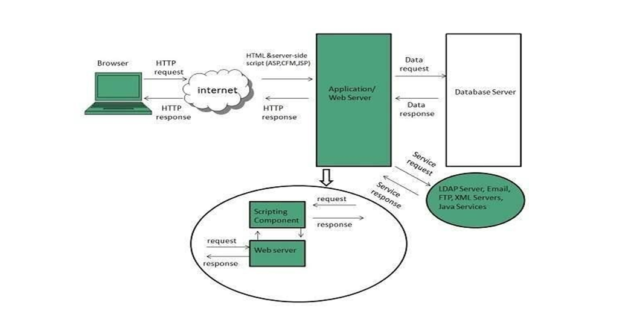

**Fig 1.2.2(1)**

* + 1. **Database:**

A database is an organized collection of [data. I](https://en.wikipedia.org/wiki/Data_%28computing%29)t is the collection of [schemas, tables,](https://en.wikipedia.org/wiki/Database_schema) [queries, r](https://en.wikipedia.org/wiki/Query_language)eports, [views,](https://en.wikipedia.org/wiki/View_%28SQL%29) and other objects. The data are typically organized to model aspects of reality in a way that supports [processes r](https://en.wikipedia.org/wiki/Process_%28computing%29)equiring information, such as modeling the availability of rooms in hotels in a way that supports finding a hotel with vacancies.

A database management system (DBMS) is a [computer software a](https://en.wikipedia.org/wiki/Computer_software)pplication that interacts with the user, other applications, and the database itself to capture and analyze data. A general-purpose DBMS is designed to allow the definition, creation, querying, update, and administration of databases. Well-known DBMSs include [MySQL, PostgreSQL,](https://en.wikipedia.org/wiki/MySQL) [MongoDB,](https://en.wikipedia.org/wiki/MongoDB) [MariaDB](https://en.wikipedia.org/wiki/MariaDB)[, Microsoft SQL Server](https://en.wikipedia.org/wiki/Microsoft_SQL_Server)[, Oracl](https://en.wikipedia.org/wiki/Oracle_Database)[e, Sybase,](https://en.wikipedia.org/wiki/Sybase) [SAP HANA, MemSQL a](https://en.wikipedia.org/wiki/SAP_HANA)nd A database is not generally [portable a](https://en.wikipedia.org/wiki/Software_portability)cross different DBMSs, but different DBMS can interoperate by using [standards su](https://en.wikipedia.org/wiki/Technical_standard)ch as

[SQL a](https://en.wikipedia.org/wiki/SQL)nd [ODBC or](https://en.wikipedia.org/wiki/ODBC) [JDBC to](https://en.wikipedia.org/wiki/JDBC) allow a single application to work with more than one DBMS. Sometimes a DBMS is loosely referred to as a "database".

* + 1. **SQL:**

Originally based upon [relational algebra a](https://en.wikipedia.org/wiki/Relational_algebra)nd [tuple relational calculus,](https://en.wikipedia.org/wiki/Tuple_relational_calculus) SQL consists of a [data definition language,](https://en.wikipedia.org/wiki/Data_definition_language) [data manipulation language,](https://en.wikipedia.org/wiki/Data_manipulation_language) and [data control language.](https://en.wikipedia.org/wiki/Data_control_language) The scope of SQL includes data insert, query, update and delete, [schema c](https://en.wikipedia.org/wiki/Database_schema)reation and modification, and data access control. Although SQL is often described as, and to a great extent is, a [declarative language](https://en.wikipedia.org/wiki/Declarative_programming) ([4GL),](https://en.wikipedia.org/wiki/4GL) it also includes [procedural e](https://en.wikipedia.org/wiki/Procedural_programming)lements.

SQL was one of the first commercial languages for [Edgar F. Codd'](https://en.wikipedia.org/wiki/Edgar_F._Codd)[srelational model,](https://en.wikipedia.org/wiki/Relational_model) as described in his influential 1970 paper, "A Relational Model of Data for Large Shared Data Banks." Despite not entirely adhering to [the relational model as described by Codd, it](https://en.wikipedia.org/wiki/Codd%27s_12_rules) became the most widely used database language.

SQL became a [standard of](https://en.wikipedia.org/wiki/Technical_standard) the [American National Standards Institute (](https://en.wikipedia.org/wiki/American_National_Standards_Institute)ANSI) in 1986, and of the [International Organization for Standardization (](https://en.wikipedia.org/wiki/International_Organization_for_Standardization)ISO) in 1987. Since then, the standard has been revised to include a larger set of features. Despite the existence of such standards, most SQL code is not completely portable among different database systems without adjustments.

* + 1. **Queries:**

The most common operation in SQL, the query, makes use of the declarative [SELECT](https://en.wikipedia.org/wiki/Select_%28SQL%29) statement. SELECT retrieves data from one or more [tables, or](https://en.wikipedia.org/wiki/Table_%28database%29) expressions. Standard SELECT statements have no persistent effects on the database. Some non-standard implementations of SELECT can have persistent effects, such as the SELECT INTO syntax provided in some databases.

Queries allow the user to describe desired data, leaving the [database management system (DBMS) to](https://en.wikipedia.org/wiki/Database_management_system) carry out [planning,](https://en.wikipedia.org/wiki/Query_plan) [optimizing an](https://en.wikipedia.org/wiki/Query_optimizer)d performing the physical operations necessary to produce that result as it chooses.

A query includes a list of columns to include in the final result, normally immediately following the SELECT keyword. An asterisk ("*") can be used to specify that the query should return all columns of the queried tables. SELECT is the most complex statement in SQL, with optional keywords and clauses that include:

* 1. **Scripting Languages:**

### **1.3.1 NodeJS**

Node.js is an open source, cross-platform runtime environment for developing server-side and networking applications. Node.js applications are written in JavaScript, and can be run within the Node.js runtime on OS X, Microsoft Windows, and Linux.

Node.js also provides a rich library of various JavaScript modules which simplifies the development of web applications using Node.js to a great extent.

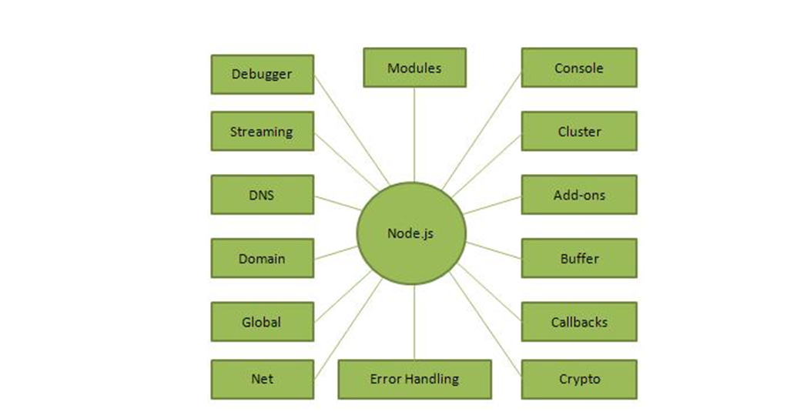

**FIG 1.3.1 USES OF NODE.JS**

**1.3.2. HISTORY**

Node.js was written initially by Ryan Dahl in 2009,[24] about thirteen years after the introduction of the first server-side JavaScript environment, Netscape's Livewire Pro Web.[25] The initial release supported only Linux and Mac OS X. Its development and maintenance was led by Dahl and later sponsored by Joyent.

In June 2011, Microsoft and Joyent implemented a native Windows version of Node.js. The first Node.js build supporting Windows was released in July 2011.

**ADVANTAGES OF NODEJS**

**Asynchronous and Event Driven** − All APIs of Node.js library are asynchronous, that is, non-blocking. It essentially means a Node.js based server never waits for an API to return data. The server moves to the next API after calling it and a notification mechanism of Events of Node.js helps the server to get a response from the previous API call.

**Very Fast** − Being built on Google Chrome's V8 JavaScript Engine, Node.js library is very fast in code execution.

**Single Threaded but Highly Scalable** − Node.js uses a single threaded model with event looping. Event mechanism helps the server to respond in a non-blocking way and makes the server highly scalable as opposed to traditional servers which create limited threads to handle requests. Node.js uses a single threaded program and the same program can provide service to a much larger number of requests than traditional servers like Apache HTTP Server.

**No Buffering** − Node.js applications never buffer any data. These applications simply output the data in chunks.

**DISDVANTAGES OF NODEJS**

**Not efficient in handling CPU-intensive apps.** Being an event-based and a single threaded environment, Node.js is not suitable because it is not efficient enough to handle CPU-intensive apps. Generating audio, video, or editing graphics etc are some concurrent requests which cannot be managed by Node.js.

**Not mature enough.** Node provides the developers with the access to a bunch of third-party modules already developed by the community. But this entire ecosystem is still pretty immature. The bugs and inconsistent version makes it unsuitable for the maintaining team.

### **JAVA SCRIPT**

**JavaScript**, often abbreviated as "JS", is a [high-level](https://en.wikipedia.org/wiki/High-level_programming_language), [dynamic,](https://en.wikipedia.org/wiki/Dynamic_programming_language) [untyped](https://en.wikipedia.org/wiki/Untyped_language), and [interpreted](https://en.wikipedia.org/wiki/Interpreted_language) run-time [language.](https://en.wikipedia.org/wiki/Programming_language) It has been standardized in the [ECMAScript](https://en.wikipedia.org/wiki/ECMAScript) language specification. Alongside [HTML](https://en.wikipedia.org/wiki/HTML) and [CSS,](https://en.wikipedia.org/wiki/CSS) JavaScript is one of the three core technologies of [World Wide Web content production](https://en.wikipedia.org/wiki/World_Wide_Web); the majority of [websites](https://en.wikipedia.org/wiki/Website) employ it, and all modern [Web](https://en.wikipedia.org/wiki/Web_browser) [browsers](https://en.wikipedia.org/wiki/Web_browser) support it without the need for [plug-ins.](https://en.wikipedia.org/wiki/Browser_extension) JavaScript is [prototype-based](https://en.wikipedia.org/wiki/Prototype-based_programming) with [first-class](https://en.wikipedia.org/wiki/First-class_function) [functions,](https://en.wikipedia.org/wiki/First-class_function) making it a [multi-paradigm](https://en.wikipedia.org/wiki/Multi-paradigm) language, supporting [object-oriented](https://en.wikipedia.org/wiki/Object-oriented_programming), [imperative](https://en.wikipedia.org/wiki/Imperative_programming), and [functional programming styles.](https://en.wikipedia.org/wiki/Functional_programming) It has an [API](https://en.wikipedia.org/wiki/Application_programming_interface) for working with text, [arrays](https://en.wikipedia.org/wiki/Array_data_type), dates and [regular](https://en.wikipedia.org/wiki/Regular_expression) [expressions](https://en.wikipedia.org/wiki/Regular_expression), but does not include any [I/O,](https://en.wikipedia.org/wiki/Input/output) such as networking, storage, or graphics facilities, relying for these upon the host environment in which it is embedded.

Although there are strong outward similarities between JavaScript and Java, including language name, [syntax](https://en.wikipedia.org/wiki/Syntax_%28programming_languages%29), and respective [standard libraries,](https://en.wikipedia.org/wiki/Standard_library) the two are distinct languages and differ greatly in their design. JavaScript was influenced by programming languages such as [self](https://en.wikipedia.org/wiki/Self_%28programming_language%29) and [Scheme.](https://en.wikipedia.org/wiki/Scheme_%28programming_language%29)

JavaScript is also used in environments that are not Web-based, such as [PDF](https://en.wikipedia.org/wiki/Portable_Document_Format) documents, [site-specific browsers,](https://en.wikipedia.org/wiki/Site-specific_browser) and [desktop widgets.](https://en.wikipedia.org/wiki/Desktop_widget) Newer and faster JavaScript [virtual](https://en.wikipedia.org/wiki/Virtual_machine) [machines](https://en.wikipedia.org/wiki/Virtual_machine) (VMs) and platforms built upon them have also increased the popularity of JavaScript for [server-side Web applications](https://en.wikipedia.org/wiki/Server-side). On the [client side](https://en.wikipedia.org/wiki/Client_side), developers have traditionally implemented JavaScript as an [interpreted](https://en.wikipedia.org/wiki/Interpreter_%28computing%29) language, but more recent browsers perform [just-in-time](https://en.wikipedia.org/wiki/Just-in-time_compilation) [compilation](https://en.wikipedia.org/wiki/Just-in-time_compilation). Programmers also use JavaScript in [video-game development](https://en.wikipedia.org/wiki/Video_game_development), in crafting desktop and mobile applications, and in server-side [network programming](https://en.wikipedia.org/wiki/Computer_network_programming) with [run-time environments](https://en.wikipedia.org/wiki/Runtime_system) such as [Node.js.](https://en.wikipedia.org/wiki/Node.js)

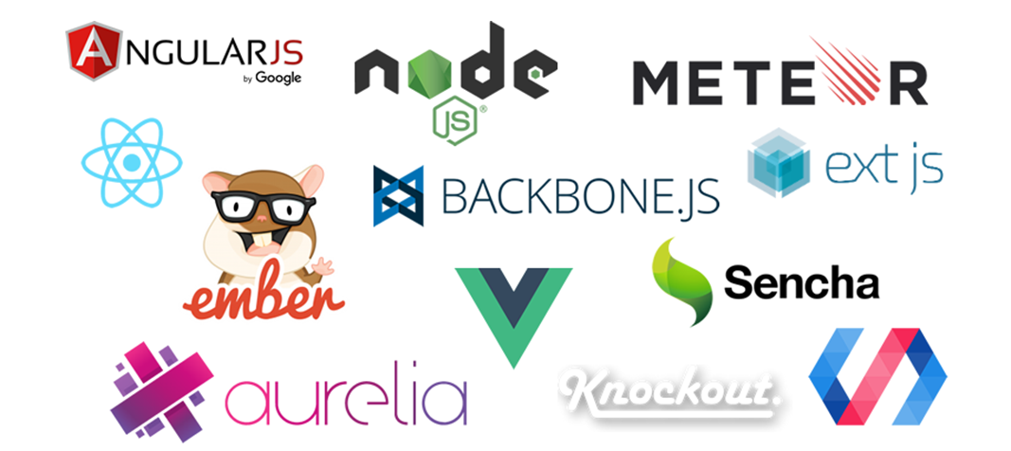

**Fig 1.3.3**

### **JQUERY**

**JQuery** is a [cross-platform](https://en.wikipedia.org/wiki/Cross-platform) [JavaScript library](https://en.wikipedia.org/wiki/JavaScript_library) designed to simplify the [client-side](https://en.wikipedia.org/wiki/Client-side_scripting) [scripting](https://en.wikipedia.org/wiki/Client-side_scripting) of [HTML.](https://en.wikipedia.org/wiki/HTML) It is [free, open-source software](https://en.wikipedia.org/wiki/Free_and_open_source_software) using the permissive [MIT license](https://en.wikipedia.org/wiki/MIT_license). [Web](https://en.wikipedia.org/wiki/World_Wide_Web) analysis indicates that it is the most widely deployed JavaScript library by a large margin.

JQuery's syntax is designed to make it easier to navigate a document, select [DOM](https://en.wikipedia.org/wiki/Document_Object_Model) elements, create [animations](https://en.wikipedia.org/wiki/Animation), handle [events,](https://en.wikipedia.org/wiki/Event_%28computing%29) and develop [Ajax](https://en.wikipedia.org/wiki/Ajax_%28programming%29) applications. JQuery also provides capabilities for developers to create [plug-ins](https://en.wikipedia.org/wiki/Plug-in_%28computing%29) on top of the JavaScript library. This enables developers to create [abstractions](https://en.wikipedia.org/wiki/Abstraction_%28computer_science%29) for low-level interaction and animation, advanced effects and high-level, theme able widgets. The modular approach to the jQuery library allows the creation of powerful [dynamic web pages](https://en.wikipedia.org/wiki/Dynamic_web_page) and Web applications.

The set of [jQuery core features](https://en.wikipedia.org/wiki/JQuery#Features)—DOM element selections, traversal and manipulation—enabled by its selector engine (named "Sizzle" from v1.3), created a new "programming style", fusing algorithms and DOM data structures. This style influenced the architecture of other [JavaScript frameworks](https://en.wikipedia.org/wiki/Comparison_of_JavaScript_frameworks) like [YUI v3](https://en.wikipedia.org/wiki/YUI_Library) and [Dojo](https://en.wikipedia.org/wiki/Dojo_Toolkit), later stimulating the creation of the standard Selectors API.

[Microsoft](https://en.wikipedia.org/wiki/Microsoft) and [Nokia](https://en.wikipedia.org/wiki/Nokia) bundle jQuery on their platforms. Microsoft includes it with [Visual Studio](https://en.wikipedia.org/wiki/Microsoft_Visual_Studio) for use within Microsoft's [ASP.NET AJAX](https://en.wikipedia.org/wiki/ASP.NET_AJAX) and [ASP.NET MVC](https://en.wikipedia.org/wiki/ASP.NET_MVC) frameworks while Nokia has integrated it into the Web Run-Time widget development platform.

### 

### **AJAX**

**Ajax** (also **AJAX** short for "asynchronous [JavaScript](https://en.wikipedia.org/wiki/JavaScript) and [XML](https://en.wikipedia.org/wiki/XML)") is a set of [Web](https://en.wikipedia.org/wiki/Web_development) [development](https://en.wikipedia.org/wiki/Web_development) techniques using many Web technologies on the [client side](https://en.wikipedia.org/wiki/Client_side) to create [asynchronous Web applications](https://en.wikipedia.org/wiki/Asynchronous_I/O). With Ajax, Web applications can send data to and retrieve from a [server](https://en.wikipedia.org/wiki/Web_server) asynchronously (in the background) without interfering with the display and behavior of the existing page. By decoupling the data interchange layer from the presentation layer, Ajax allows for Web pages, and by extension Web applications, to change content dynamically without the need to reload the entire page. In practice, modern implementations commonly substitute [JSON](https://en.wikipedia.org/wiki/JSON) for XML due to the advantages of being native to JavaScript.

Ajax is not a single technology, but rather a group of technologies. [HTML](https://en.wikipedia.org/wiki/Hypertext_Markup_Language) and [CSS](https://en.wikipedia.org/wiki/Cascading_Style_Sheets) can be used in combination to mark up and style information. The [DOM](https://en.wikipedia.org/wiki/Document_Object_Model) is accessed with JavaScript to dynamically display – and allow the user to interact with – the information presented. JavaScript and the [XMLHttpRequest](https://en.wikipedia.org/wiki/XMLHttpRequest) object provide a method for exchanging data asynchronously between browser and server to avoid full page reloads.

### **1.3.6 JSON**

[In computing,](https://en.wikipedia.org/wiki/Computing) **JavaScript Object Notation** or **JSON**, is an [open-](https://en.wikipedia.org/wiki/Open_standard) standard file that uses [human-readable](https://en.wikipedia.org/wiki/Human-readable_medium) text to transmit data objects consisting of [attribute–value pairs](https://en.wikipedia.org/wiki/Attribute%E2%80%93value_pair) and [array data types](https://en.wikipedia.org/wiki/Array_data_type) (or any other [serializable](https://en.wikipedia.org/wiki/Serialization) value). It is a very common data format used for [asynchronous](https://en.wikipedia.org/wiki/Asynchronous_I/O) browser/server communication, including as a replacement for [XML](https://en.wikipedia.org/wiki/XML) in some [AJAX](https://en.wikipedia.org/wiki/Ajax_%28programming%29)-style systems.

JSON is [a language-independent](https://en.wikipedia.org/wiki/Language-independent_specification) data format. It was derived from [JavaScript](https://en.wikipedia.org/wiki/JavaScript), but as of 2017 many [programming languages](https://en.wikipedia.org/wiki/Programming_language) include code to generate and [parse](https://en.wikipedia.org/wiki/Parsing) JSON-format data. The official Internet [media type](https://en.wikipedia.org/wiki/Media_type) for JSON is application/json. JSON filenames use the extension. Json.

[Douglas Crock ford](https://en.wikipedia.org/wiki/Douglas_Crockford) originally specified the JSON format in the early 2000s; two competing standards, [RFC 7159](https://tools.ietf.org/html/rfc7159) and [ECMA-404](https://www.ecma-international.org/publications/standards/Ecma-404.htm), defined it in 2013. The ECMA standard describes only the allowed syntax, whereas the RFC covers some security and interoperability considerations.[[3]](https://en.wikipedia.org/wiki/JSON#cite_note-3)

A restricted profile of JSON, known as **I-JSON** (short for "Internet JSON"), seeks to overcome some of the interoperability problems with JSON. It is defined in [RFC 7493](https://tools.ietf.org/html/rfc7493).

### 

### **1.3.7 XAMPP**



**Fig 4.3**

**Xampp** is a [free and open source cross platform](https://en.wikipedia.org/wiki/Free_software) [web server solution stack](https://en.wikipedia.org/wiki/Web_server) package developed by Apache Friends, consisting mainly of the [Apache HTTP Server](https://en.wikipedia.org/wiki/Apache_HTTP_Server), [MariaDB](https://en.wikipedia.org/wiki/MariaDB) [database](https://en.wikipedia.org/wiki/Database), and [interpreters](https://en.wikipedia.org/wiki/Interpreter_%28computing%29) for scripts written in the [PHP](https://en.wikipedia.org/wiki/PHP) and [Perl programming languages](https://en.wikipedia.org/wiki/Perl). XAMPP stands for Cross-Platform (X), Apache (A), MariaDB (M), PHP (P) and Perl (P). It is a simple, lightweight Apache distribution that makes it extremely easy for developers to create a local web server for testing and deployment purposes. Everything needed to set up a web server – server application (Apache), database (MariaDB), and scripting language (PHP) – is included in an extractable file. XAMPP is also cross-platform, which means it works equally well on Linux, Mac and Windows. Since most actual web server deployments use the same components as XAMPP, it makes transitioning from a local test server to a live server extremely easy as well.

### **FEATURES**

XAMPP is regularly updated to the latest releases of [Apache](https://en.wikipedia.org/wiki/Apache_HTTP_Server), [MariaDB](https://en.wikipedia.org/wiki/MariaDB), [PHP](https://en.wikipedia.org/wiki/PHP) and [Perl](https://en.wikipedia.org/wiki/Perl). It also comes with a number of other modules including [OpenSSL](https://en.wikipedia.org/wiki/OpenSSL), [phpMyAdmin](https://en.wikipedia.org/wiki/PhpMyAdmin), [Media Wiki](https://en.wikipedia.org/wiki/MediaWiki), [Joomla](https://en.wikipedia.org/wiki/Joomla), [Word Press](https://en.wikipedia.org/wiki/WordPress) and more. Self-contained, multiple instances of XAMPP can exist on a single computer, and any given instance can be copied from one computer to another. XAMPP is offered in both a full and a standard version (Smaller version).

**USAGE**

Officially, XAMPP's designers intended it for use only as a development tool, to allow website designers and programmers to test their work on their own computers without any access to the Internet. To make this as easy as possible, many important security features are disabled by default. XAMPP has the ability to serve web pages on the [World Wide Web.](https://en.wikipedia.org/wiki/World_Wide_Web) A special tool is provided to [password-protect](https://en.wikipedia.org/wiki/Password) the most important parts of the package.

XAMPP also provides support for creating and manipulating databases in [MariaDB](https://en.wikipedia.org/wiki/MariaDB) and [SQLite](https://en.wikipedia.org/wiki/SQLite) among others. Once XAMPP is installed, it is possible to treat a [local host](https://en.wikipedia.org/wiki/Localhost) like a remote host by connecting using an [FTP](https://en.wikipedia.org/wiki/File_Transfer_Protocol) client. Using a program like [FileZilla](https://en.wikipedia.org/wiki/FileZilla) has many advantages when installing a [content management system](https://en.wikipedia.org/wiki/Content_management_system) (CMS) like [Joomla](https://en.wikipedia.org/wiki/Joomla) or [Word Press](https://en.wikipedia.org/wiki/WordPress). It is also possible to connect to local host via FTP with an [HTML editor](https://en.wikipedia.org/wiki/HTML_editor).

**CHAPTER – 2**

**SOFTWARE REQUIRMENTS**

**2.1 Hardware Requirements:**

The selection of hardware is very important in the existence and proper working of any software. When selecting hardware, the size and requirements are also important.

|  |  |
| --- | --- |
| Processor | Intel CORE i5 |
| RAM | **4.0 GB** |
| Hard Disk Drive | **500 GB** |

**2.2 Software Requirements:**

|  |  |  |  |
| --- | --- | --- | --- |
| **Number** | **Description** | | |
| 1 | Windows 10 | | |
| 2 | HTML/Css/JavaScript/  Bootstrap. | | |
| 3 | Apache server/ XAMPSERVER | | |
| 4 | PHP | | |
| 5 | MySQL | | |
| 6 | Compiler: MSVC11 (Visual C++ 2012) | | |
| 7 | Apache version: | Apache/2.4.23 (Win32) OpenSSL/1.0.2h PHP/5.5.38 |  |
|  | | |

**CHAPTER – 3**

**PROJECT**

* 1. **Project Name:**

HOTEL BOOKING SYSTEM

The project “Hotel Booking System” is a system based on accessing the internet to book for rooms in a hotel. The purpose of this study is to develop and implement an online hotel reservation system for hotels, which will replace the manual method of booking for hotel rooms.

* 1. **Technologies used:**
* HTML
* CSS
* JavaScript
* JQuery

**Server:** Local

**Database:** MySql

**Operating System:** Windows10

**Wire framing tool:** Paint

**Team Size:** 4

* 1. **Technical Details:**
* Front end is designed using HTML, CSS and Bootstrap. JavaScript used to perform client side scripting.
* Backend is based on MySql based RDB (Relational Data Base) model. SQL queries are run using the CI SQL library functions.
* The forms are made using the HTML, Bootstrap for designing and Sql for back-end.

**CHAPTER – 4**

**MODULES**

**SCREENSHOTS:**

HOME PAGE :( html)

In the Home Page the user can find all the details about our website like rooms, galleries, Bookings, About Us and Contact details etc.

Outputs of homepage:



**Fig 4.1**

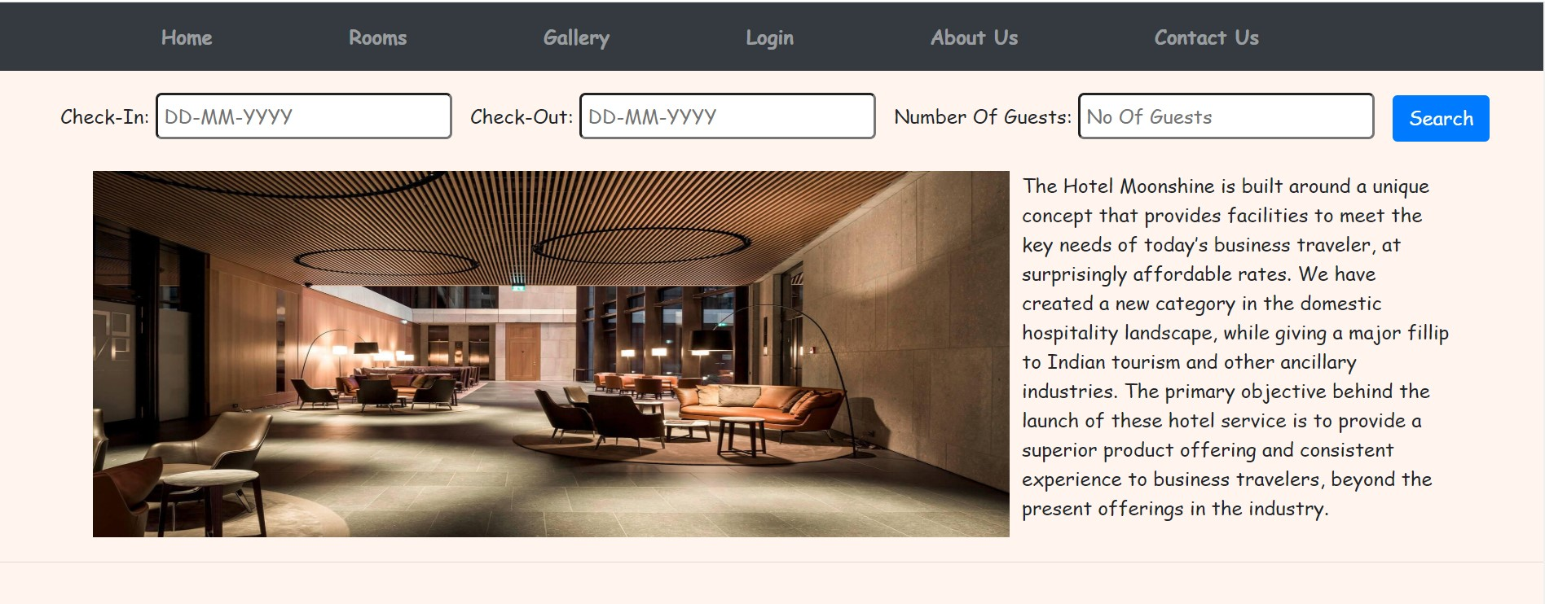

**Fig 4.1**

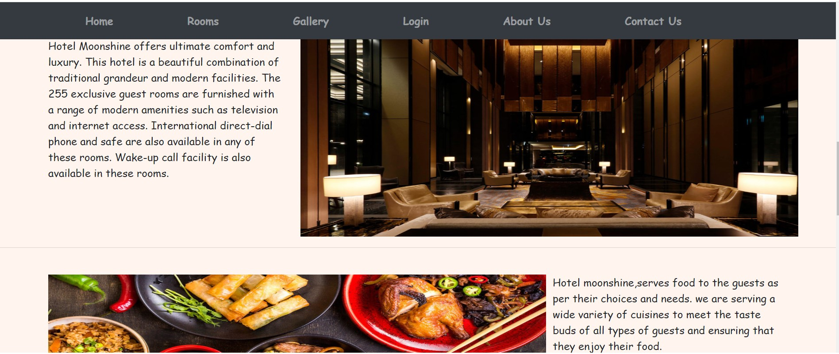

**Fig 4.1**

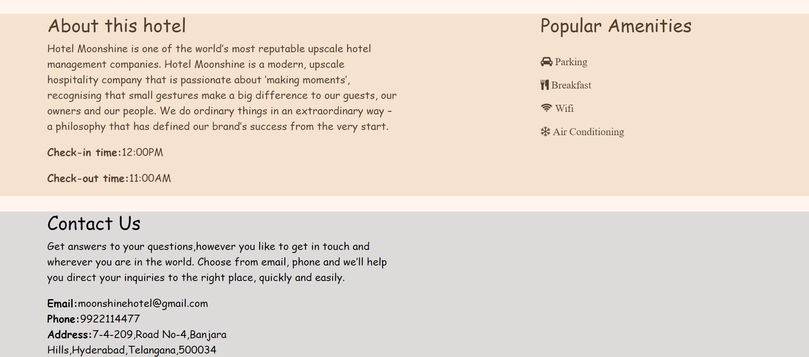

**Fig 4.1**

ROOMS PAGE :( html)

This page provides all the details about the rooms available in the hotel. When you hover over any of the room the details of that room will pe presented to you with a linear transition which is achieved with pure CSS3.

Output of rooms page:

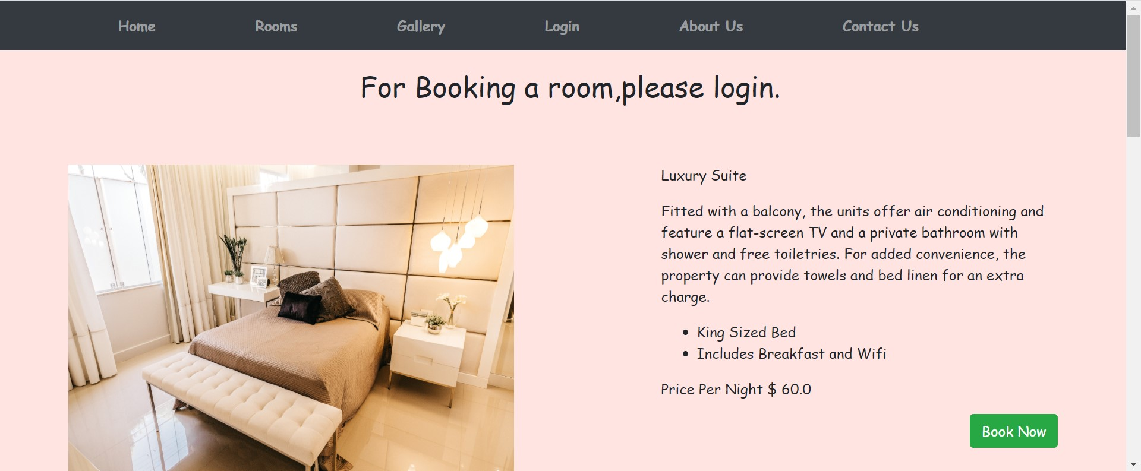

**Fig 4.2**

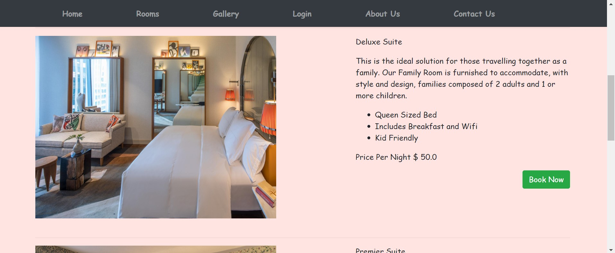

**Fig 4.2**

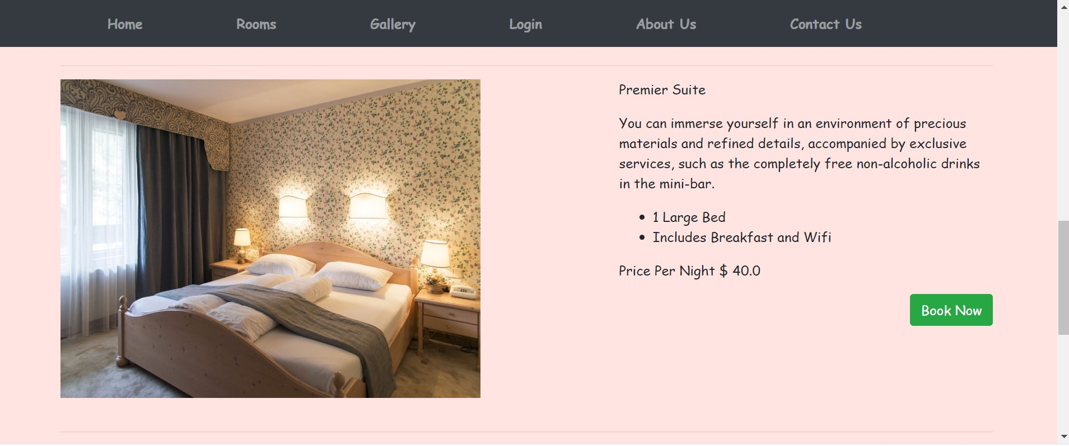

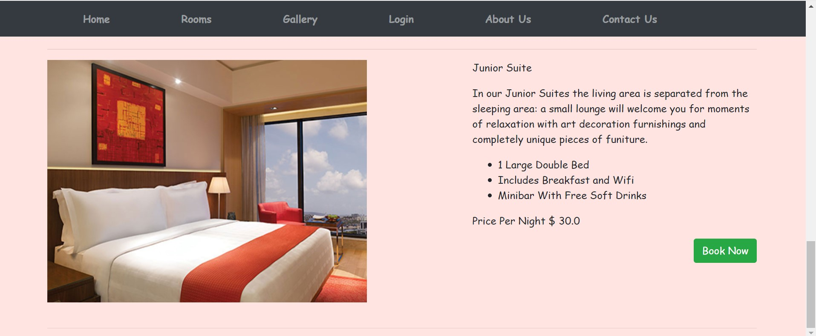

**Fig 4.2**

GALLERY PAGE: (html)

This page provides images of the hotel, we can explore over those images. New features can be easily added along with an image

Outputs of gallery page:

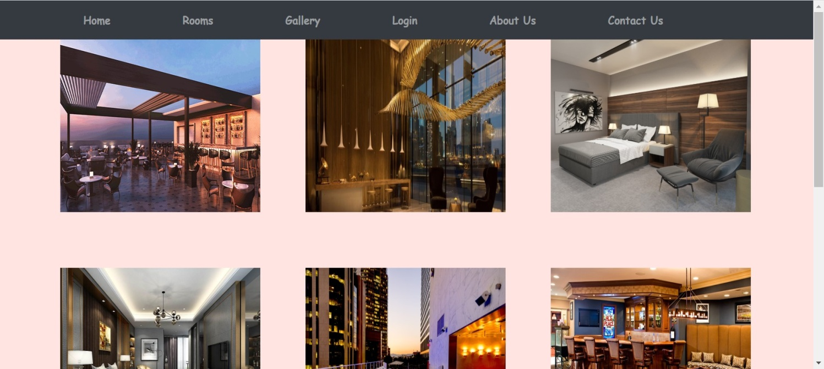

**Fig 4.3**

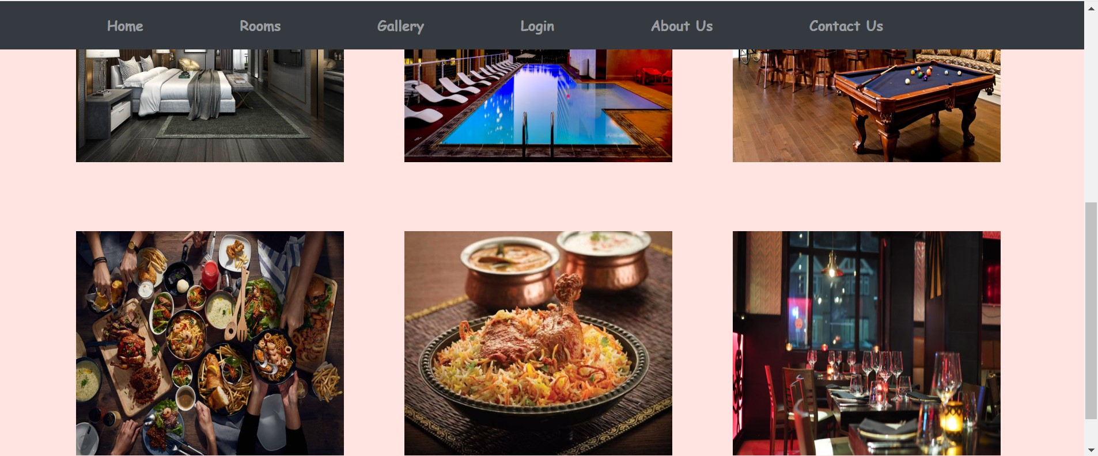

**Fig 4.3**

LOGIN & SIGNUP PAGE :( html)

It is a web page or an entry page to a website that requires user identification and authentication, regularly performed by entering a username and password combination. ... Logging in not only provides site access for the user, but also allows the website to track user actions and behavior.

Output of login & Signup page:

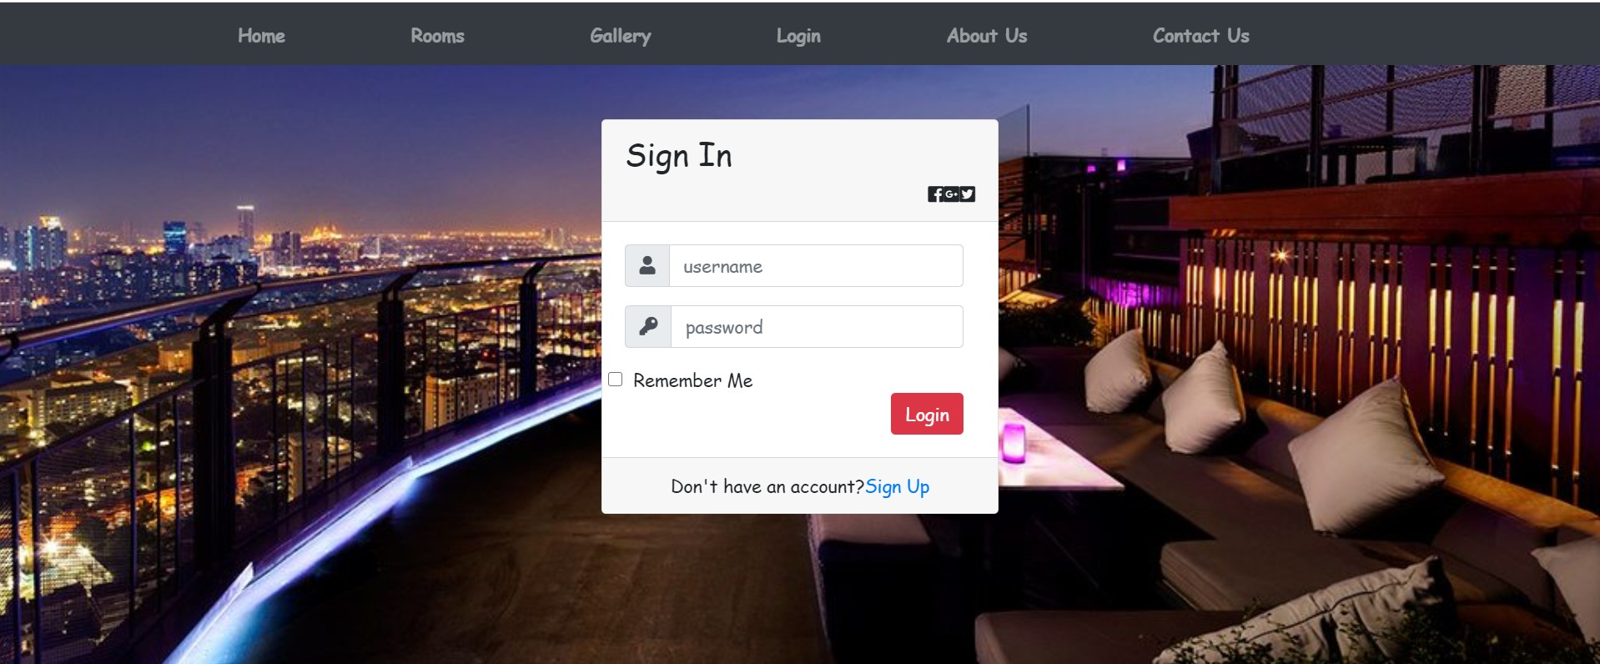

**Fig 4.4**

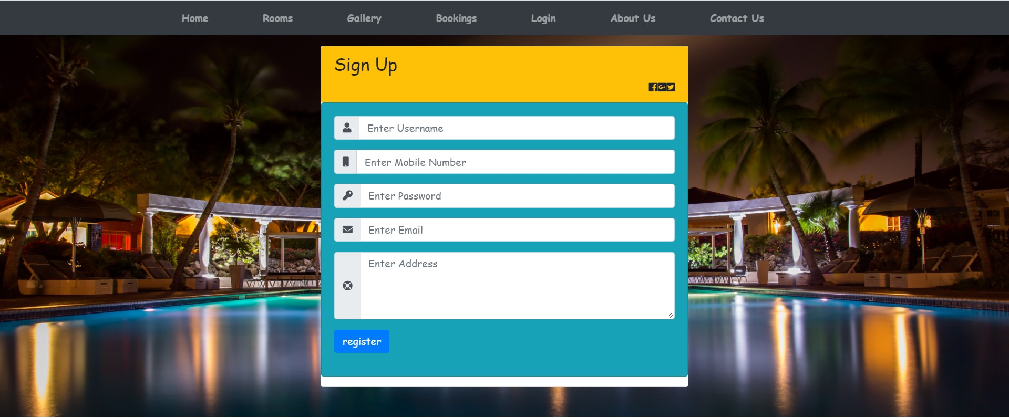

**Fig 4.4**

CONTACT US PAGE :( html)

Here the customer can get the contact details about the Hotel, along with the address and social media links

Output of contact us page:

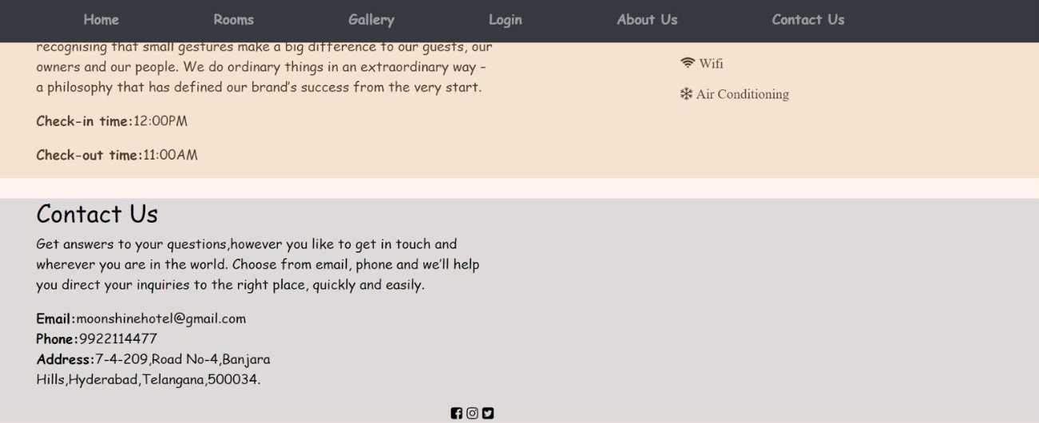

**Fig 4.5**

ABOUT PAGE: (html)

Here the user can get information about the Hotel.

Outputs of about page:

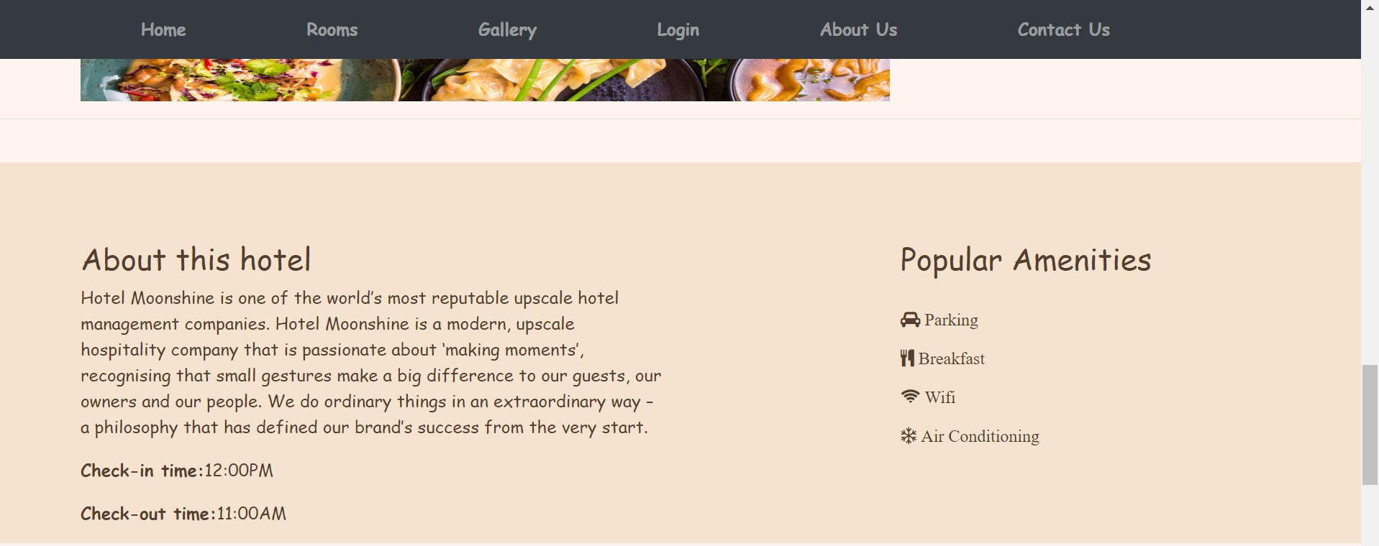

**Fig 4.6**

BOOKING PAGE :( html)

This page allows the user to book a room in the hotel.

Outputs of bookings page:

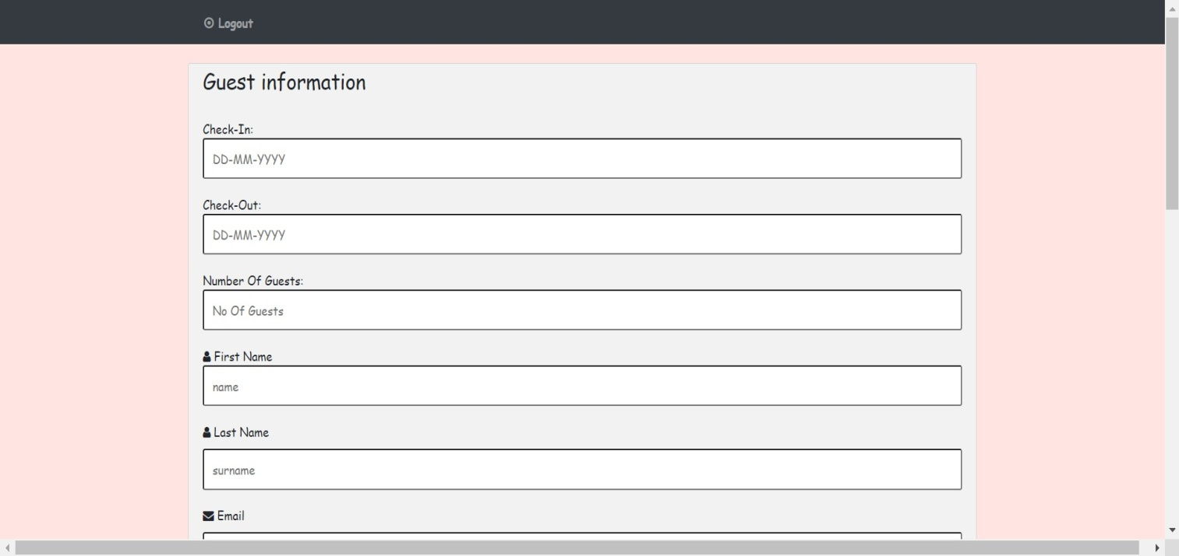

**Fig 4.7**

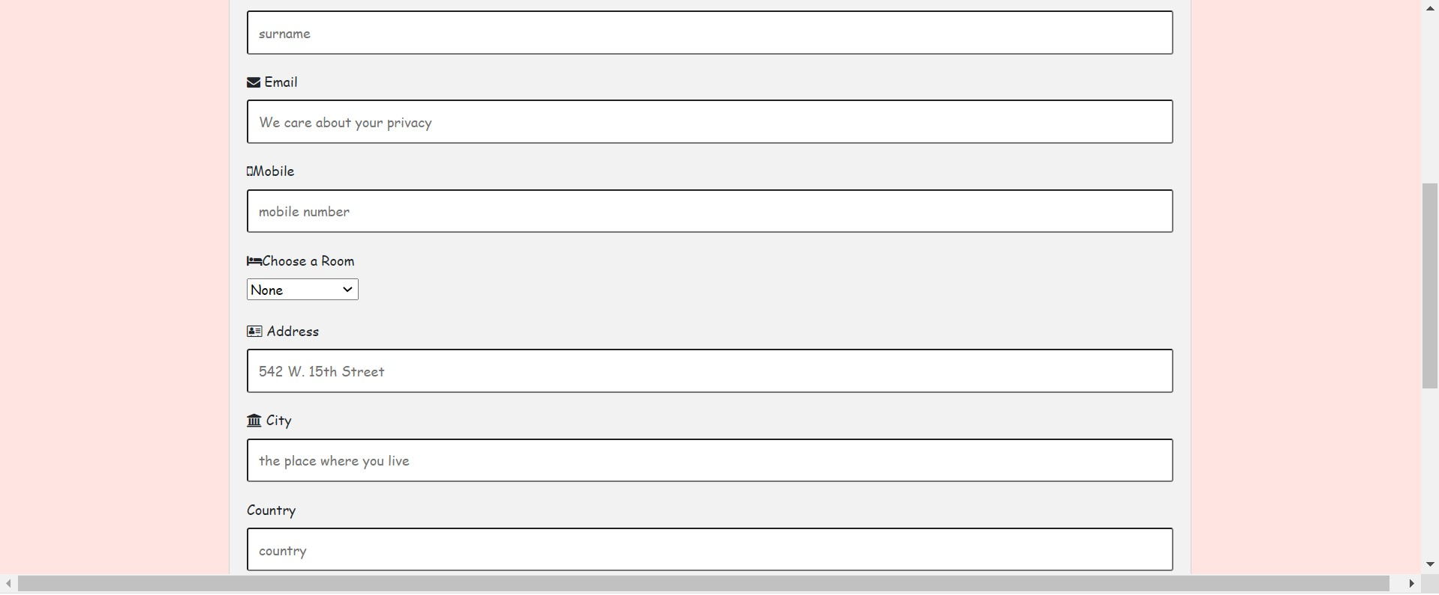

**Fig 4.7**

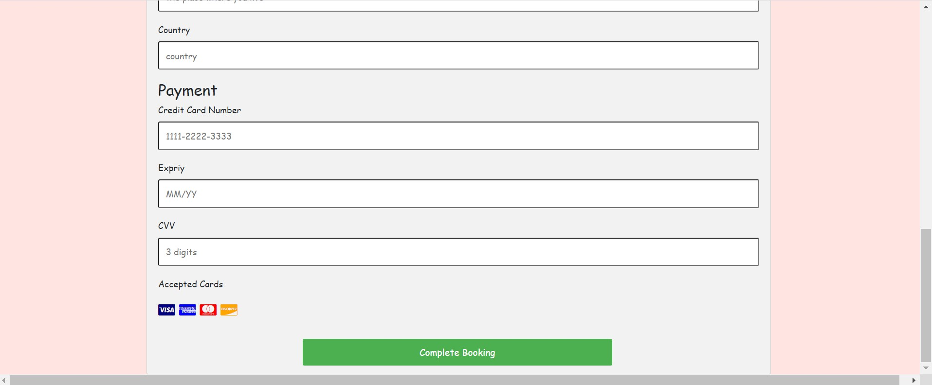

**Fig 4.7**

**CHAPTER – 5**

**OUTPUTS**

**WIREFRAMES:**

WIREFRAMES of HOME PAGE:

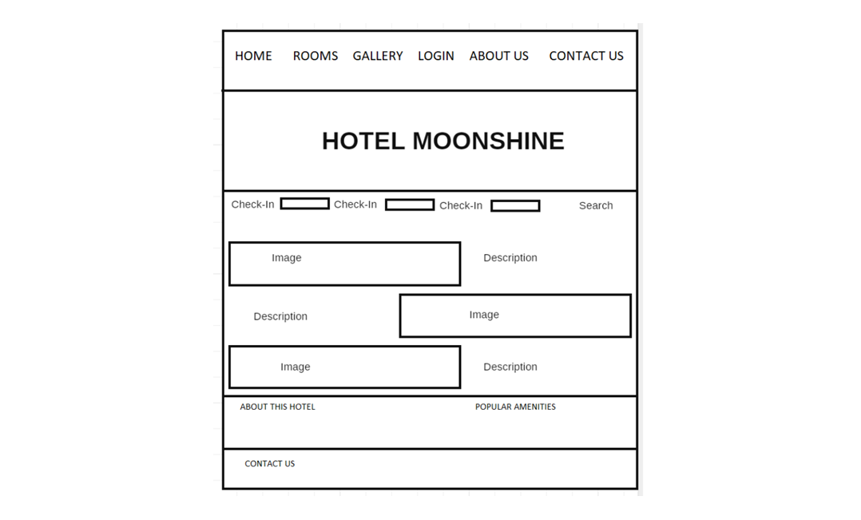

**Fig 5.1.1**

WIREFRAMES of ROOMS PAGE:

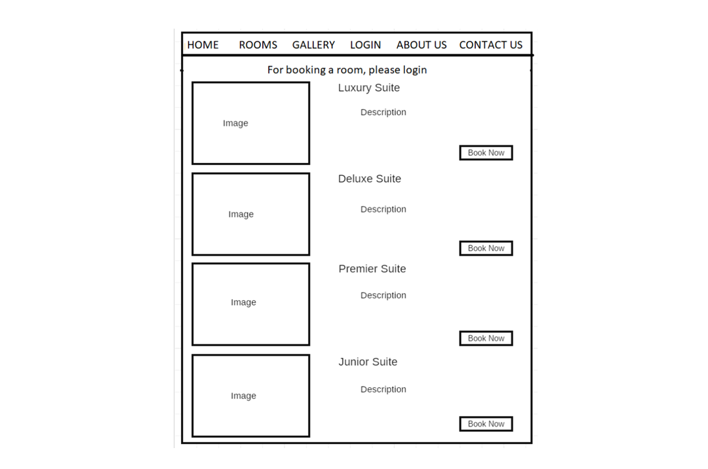

**Fig 5.1.2**

WIREFRAMES of GALLERY PAGE:

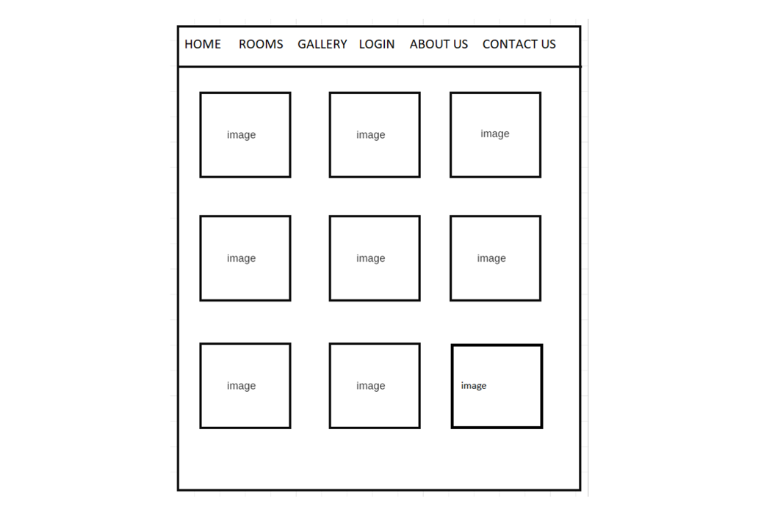

**Fig 5.1.3**

WIREFRAMES for LOGIN & SIGNUP PAGE:

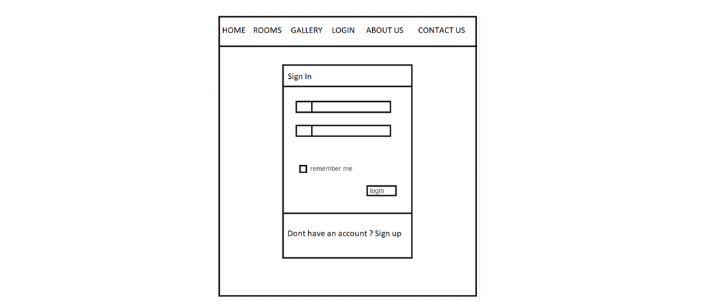

**Fig 5.1.4**

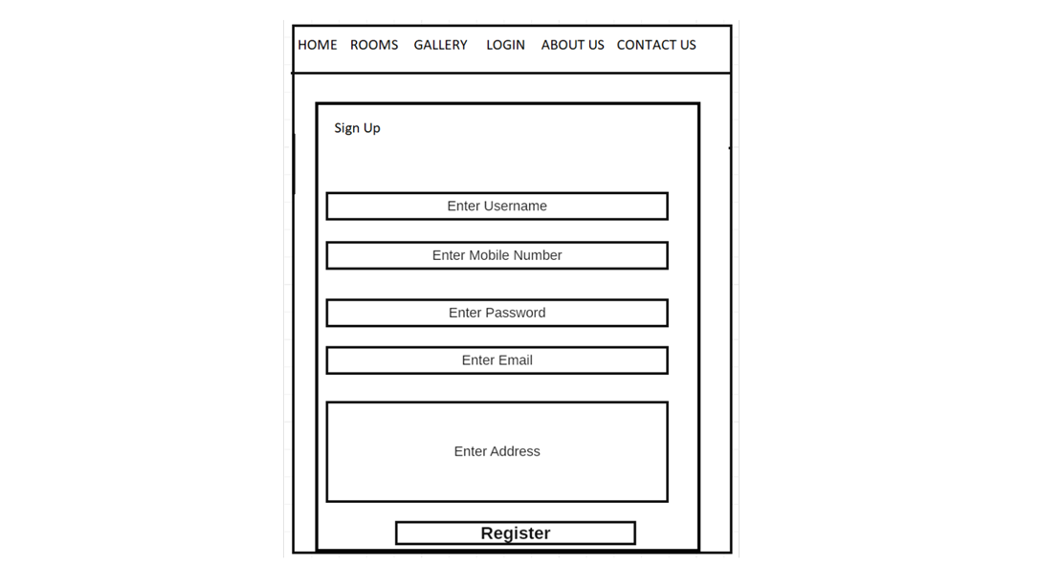

**Fig 5.1.5**

WIREFRAMES for BOOKINGS PAGE:

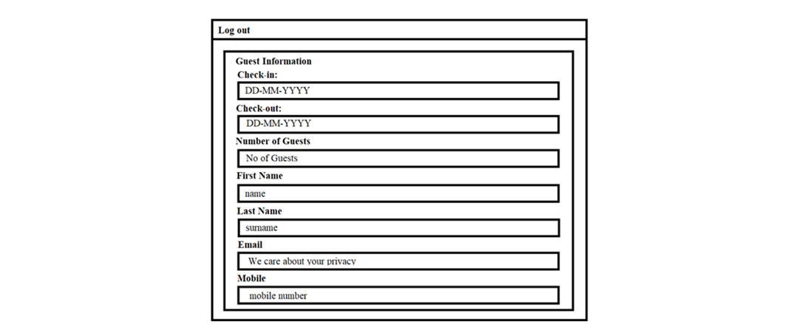

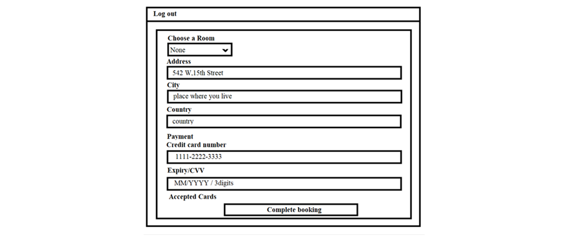

**Fig 5.1.6**

**Validations:**

Login page:

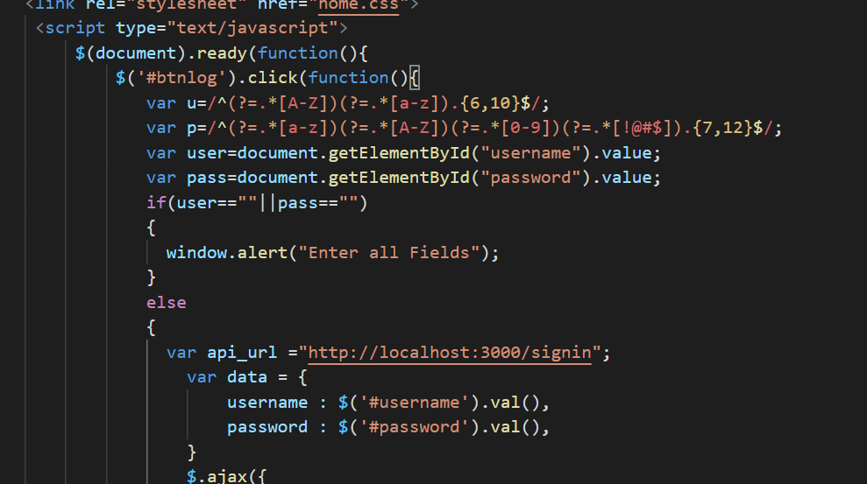

Registration page:

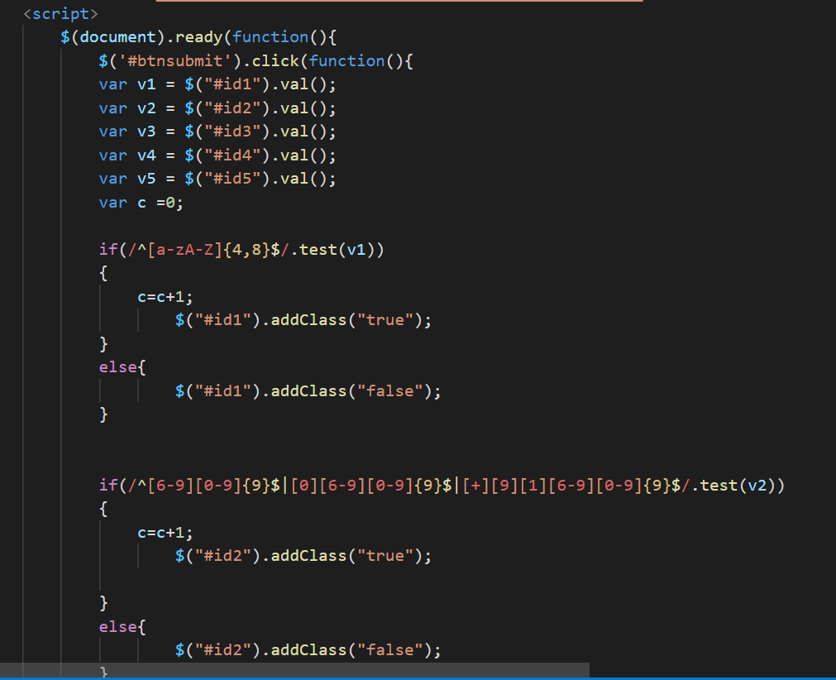

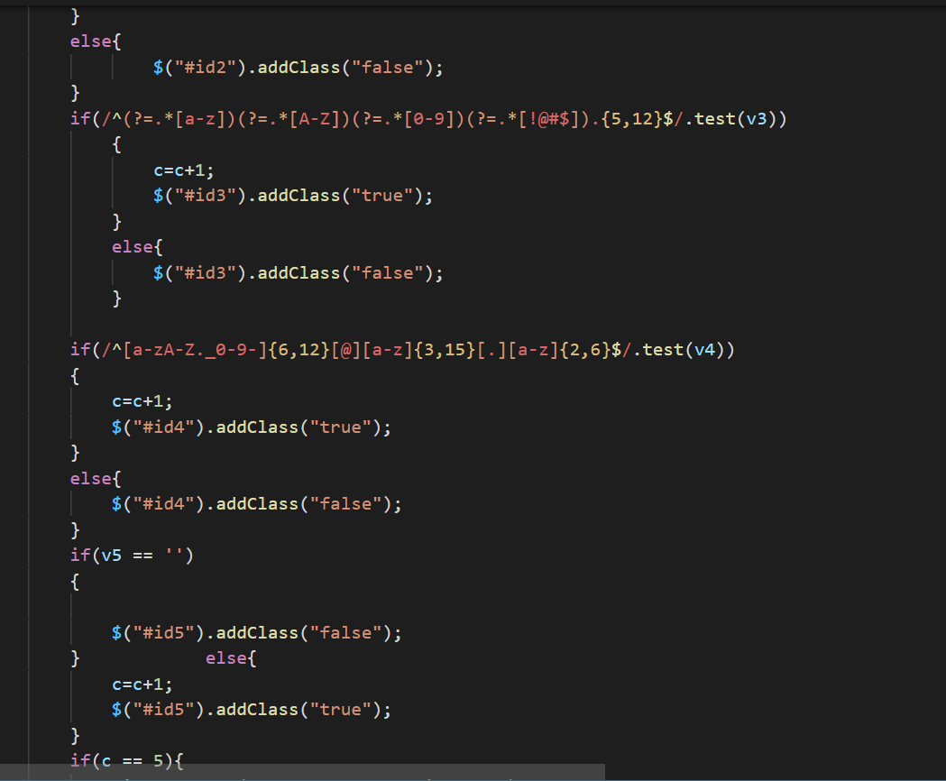

Bookings page:

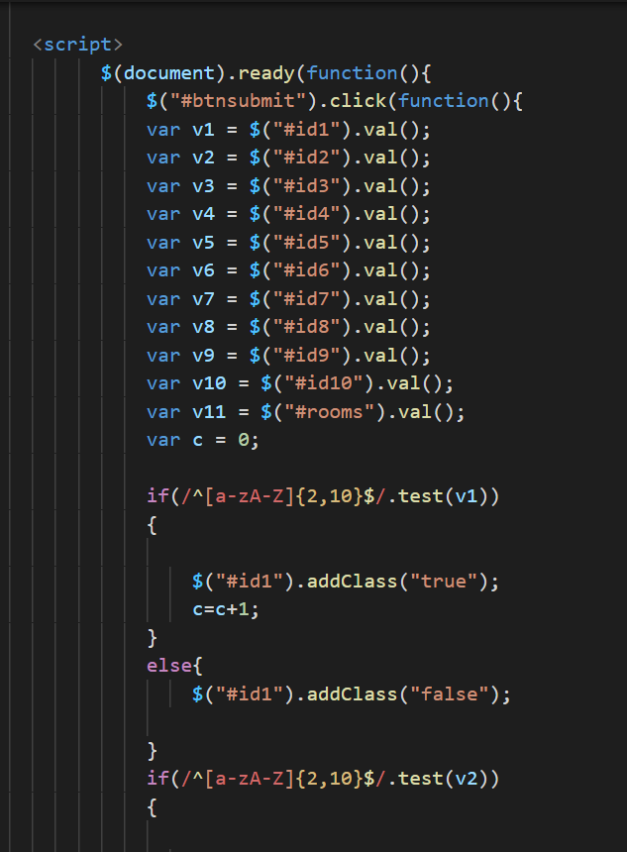

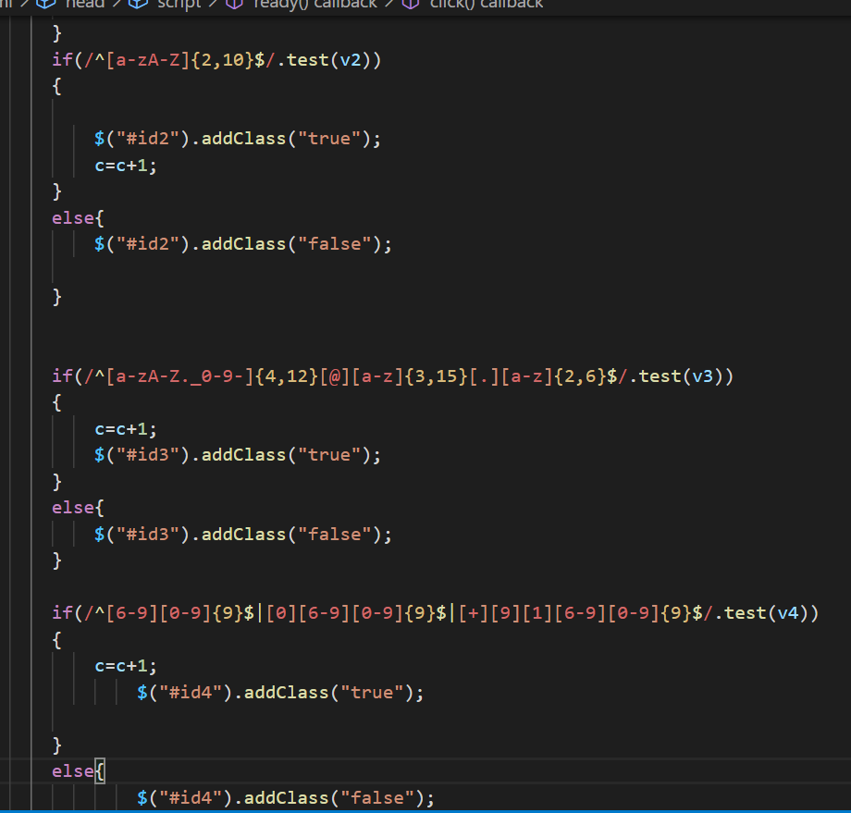

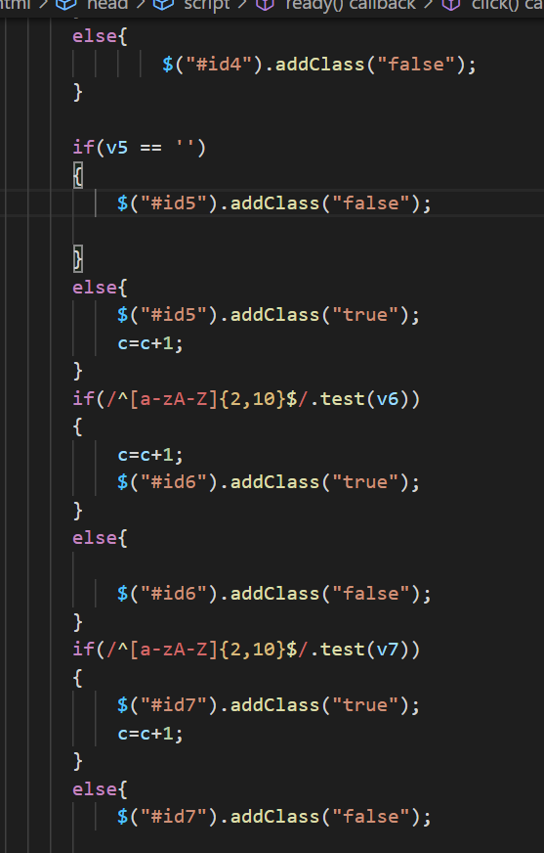

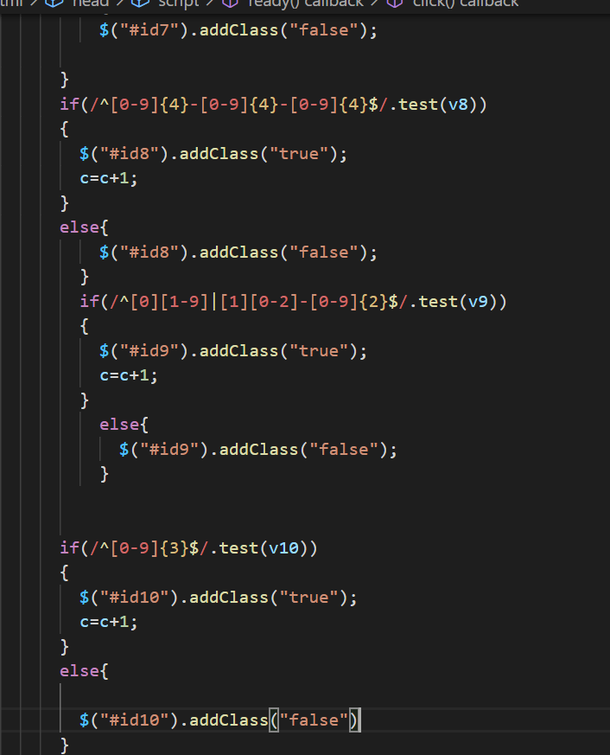

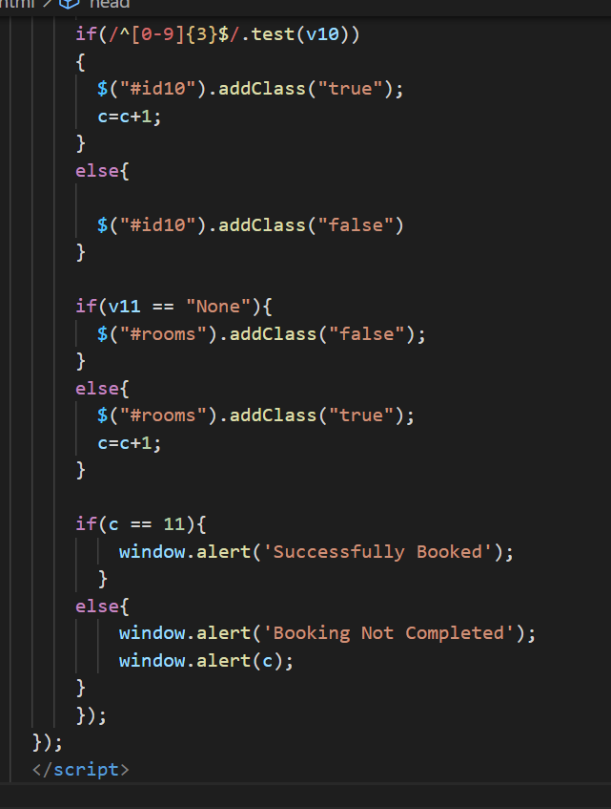

**API MYSQL CODES:**

1. Login- code

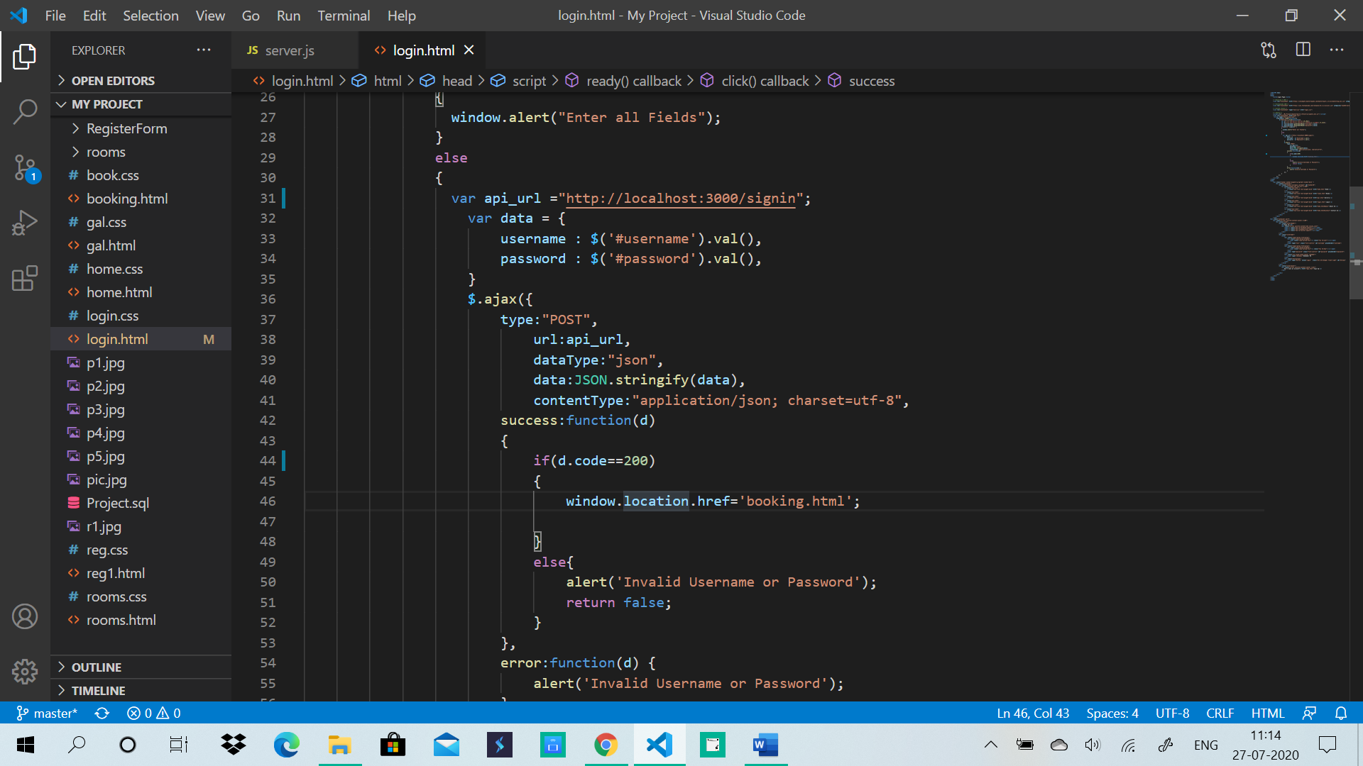

1. Registration-code

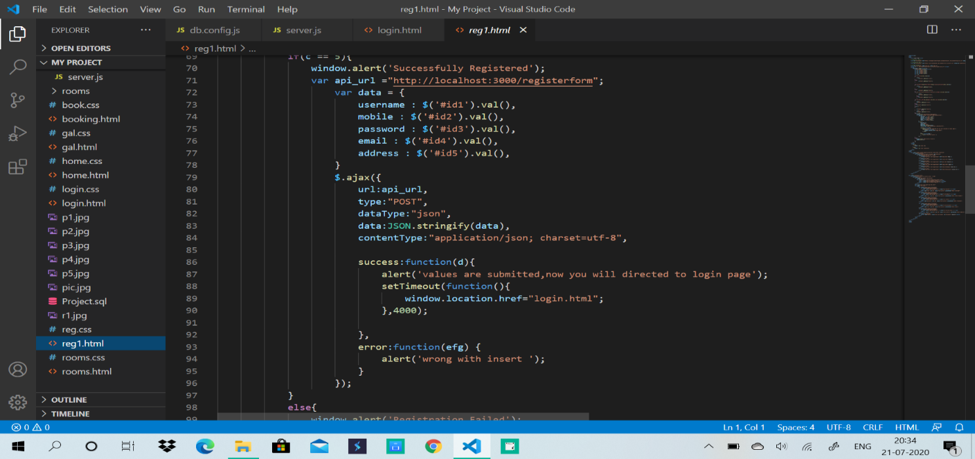

**Db.config.js:**

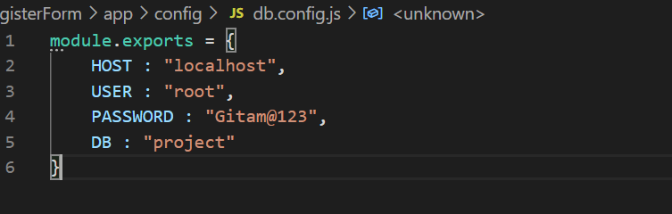

**Fig 5.2.1**

**Register.controller.js:**

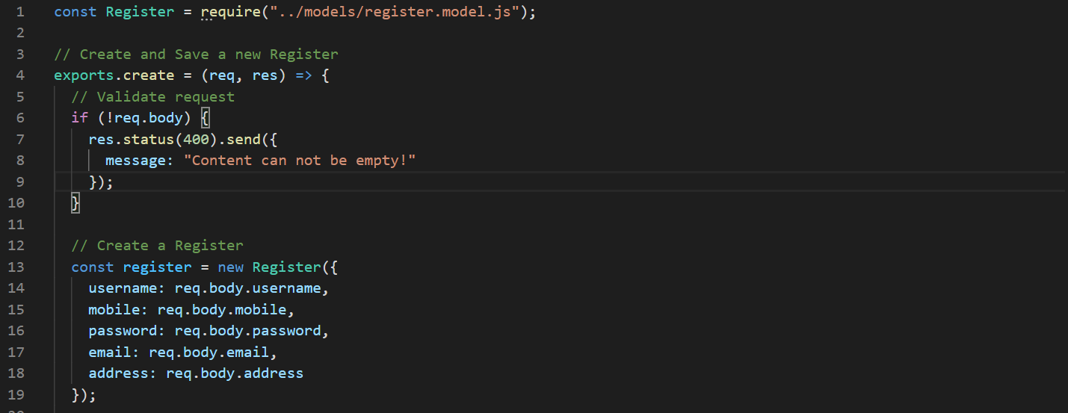

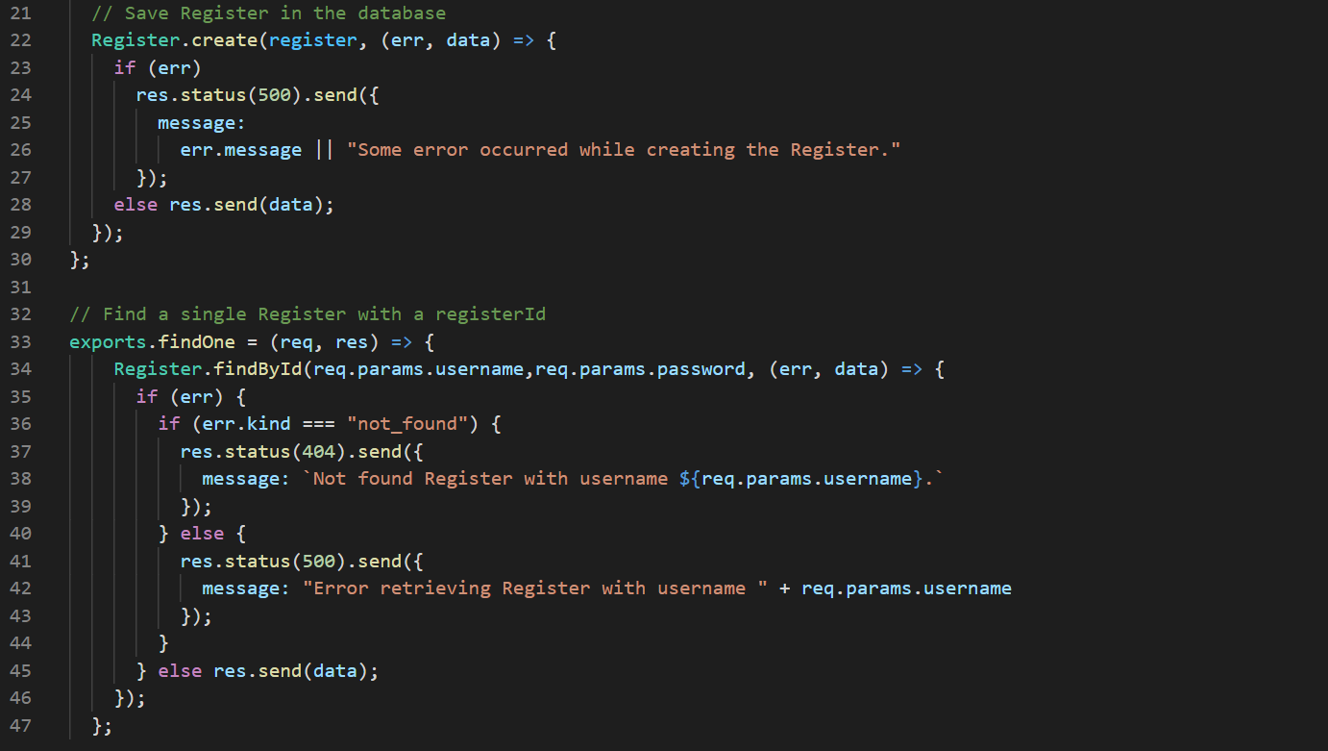

**Fig 5.2.2**

**Db.js:**

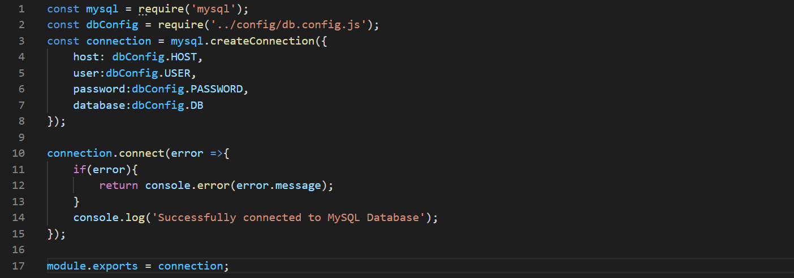**Fig 5.2.3**

**Register.model.js:**

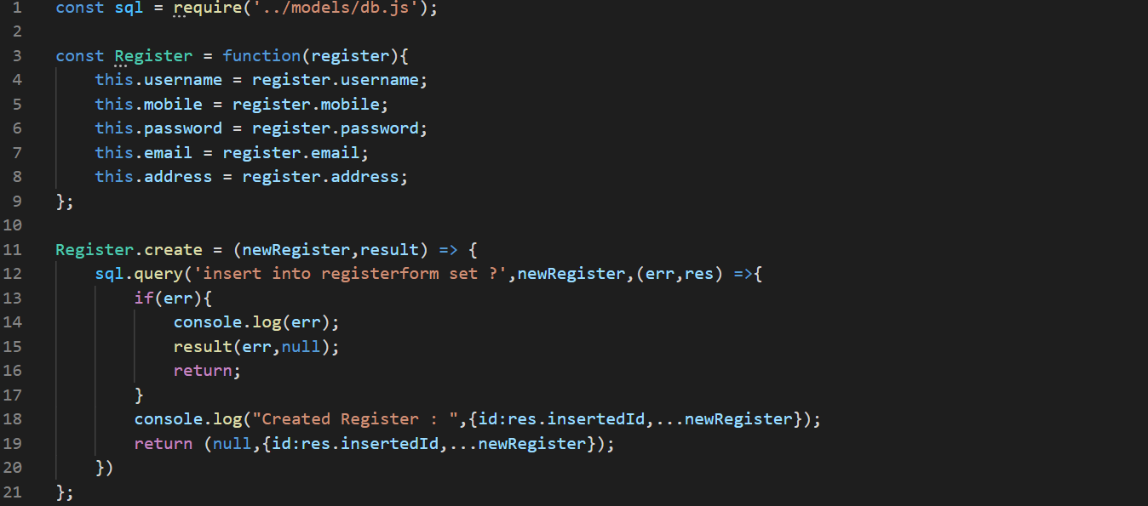

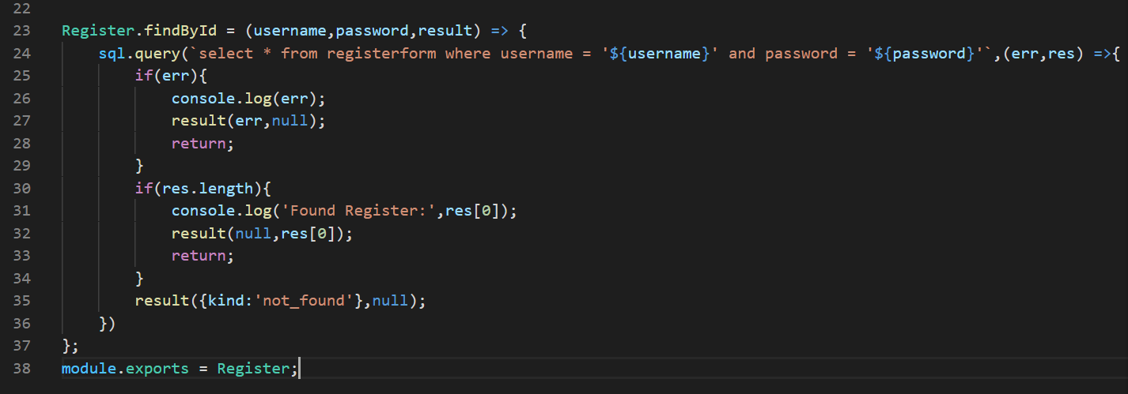

**Fig 5.2.4**

**Register.route.js:**

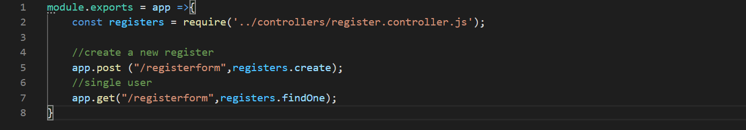

**Fig 5.2.5**

**Server.js Code:**

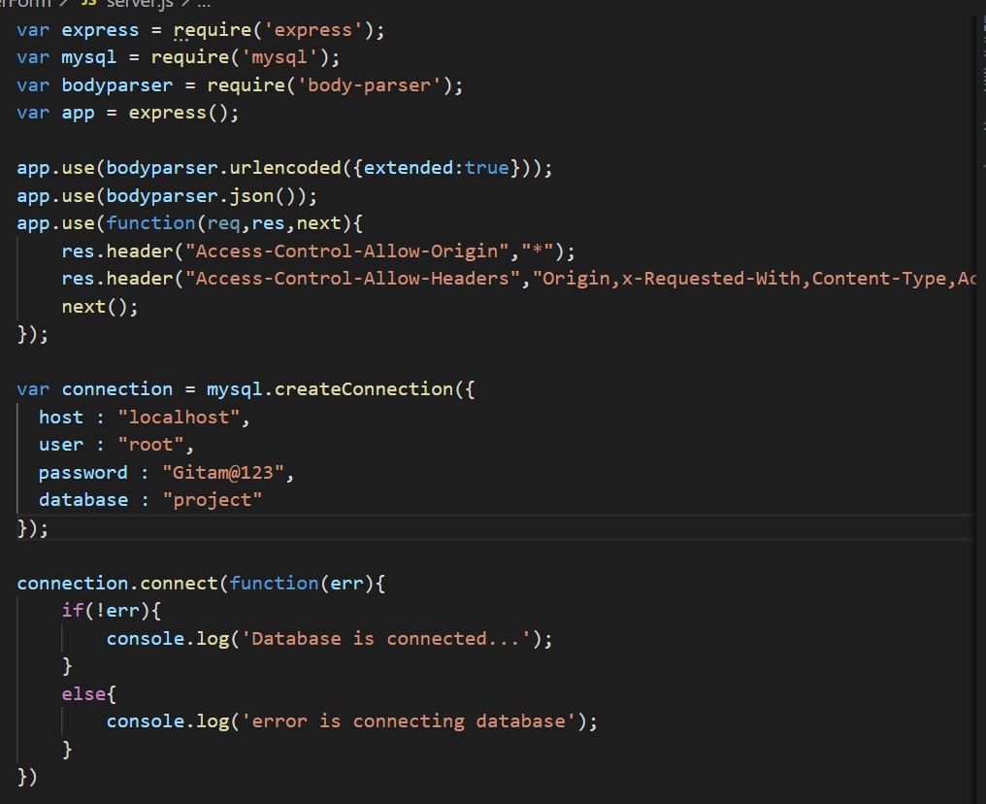

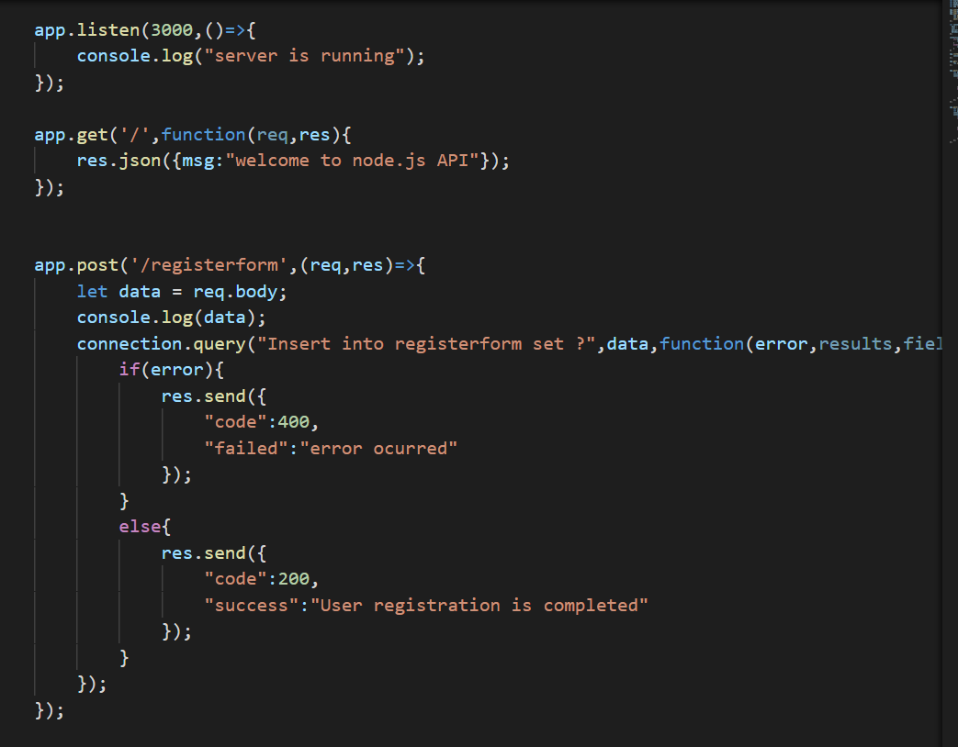

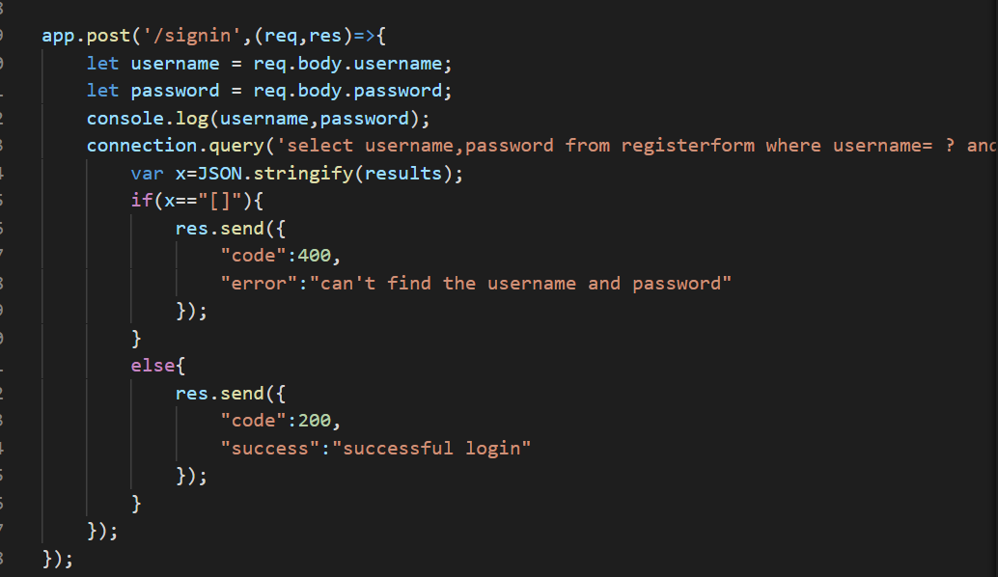

**Fig 5.2.6**

**Output:**

Connecting to Database:

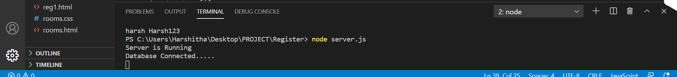

**Fig 5.3.1**

Firstly if the user is not registered, he/she can register in the Signup page:

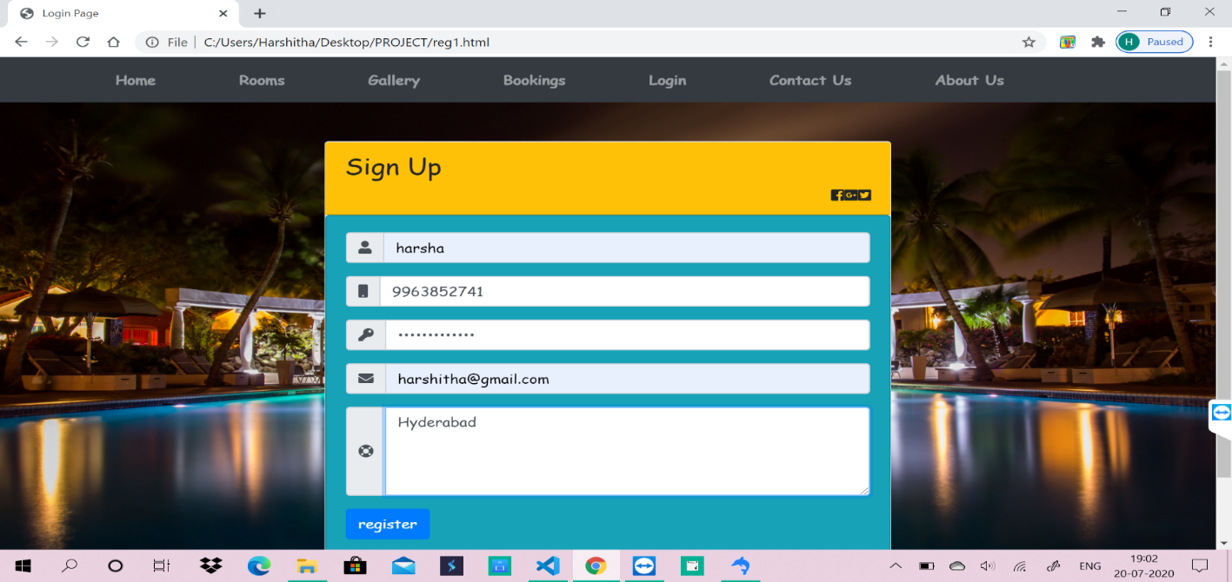

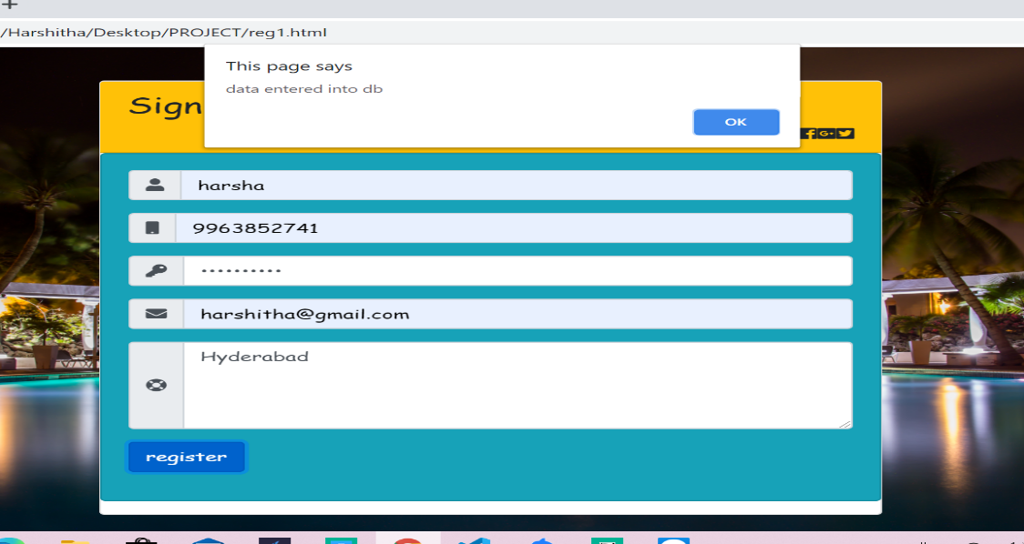

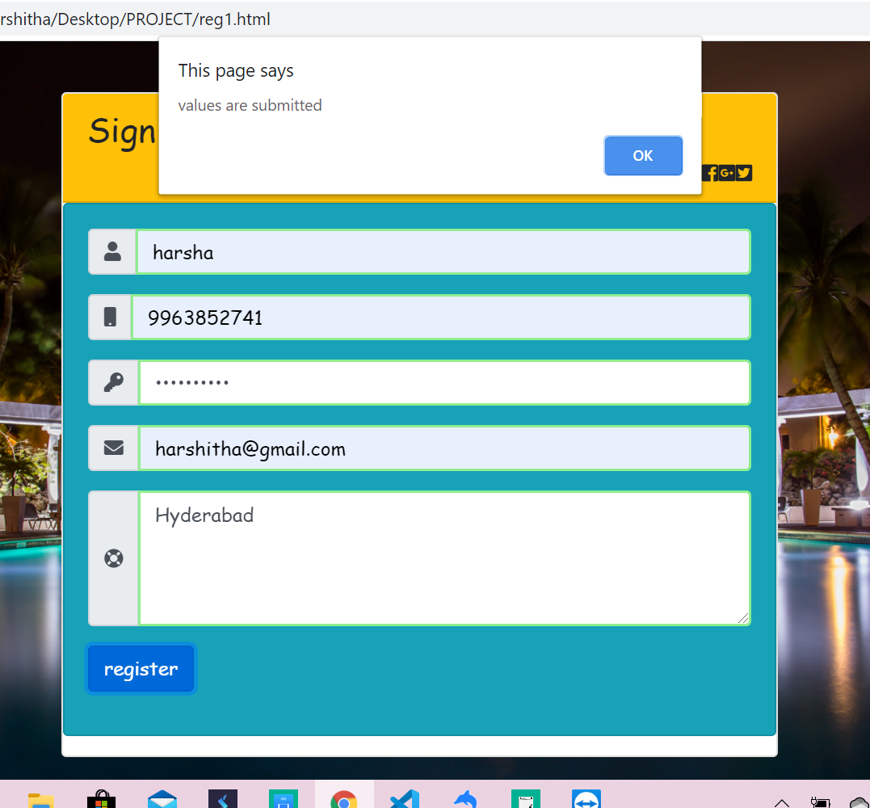

**Fig 5.3.2**

Data is entered into the database

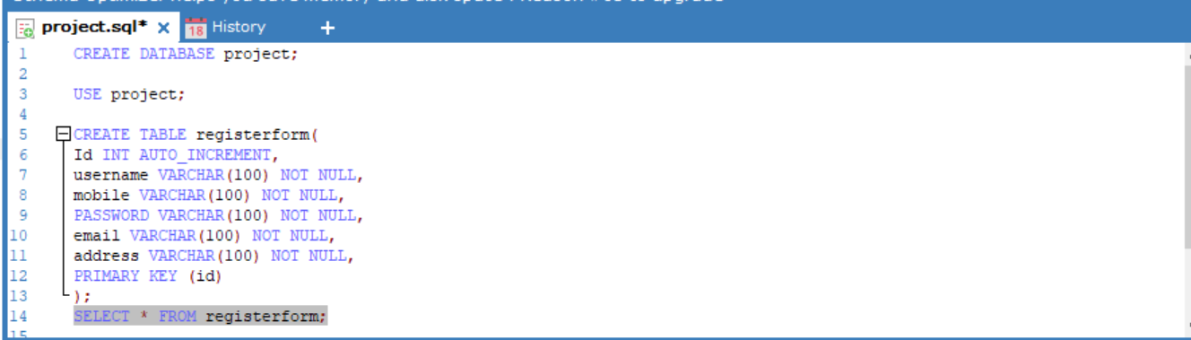

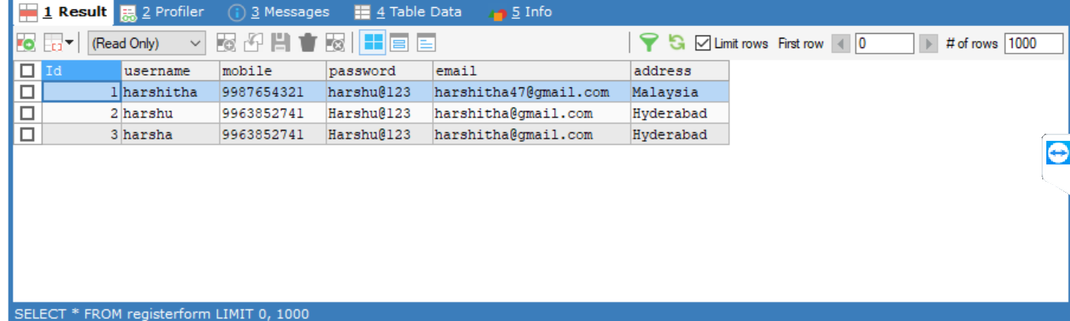

**Fig 5.3.3**

If entered data is valid then a popup appears successful login:

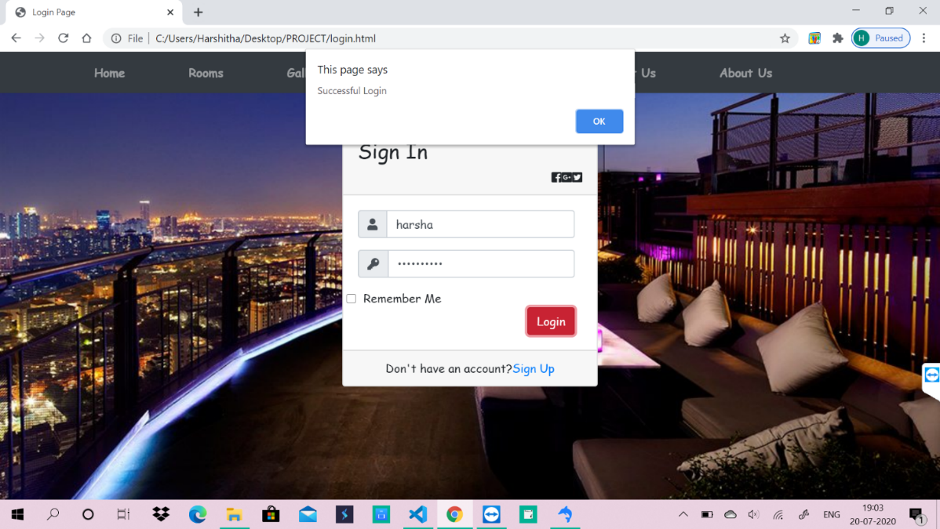

**Fig 5.3.4**

If it is Successful login then it is navigated to bookings page:







**Fig 5.3.5**

**CHAPTER – 6**

**WORKFLOW**

Class Diagram:

Class diagram is a static diagram. It represents the static view of an application. The purpose of class diagram is to model the static view of an application. Class diagrams are the only diagrams which can be directly mapped with object-oriented languages and thus widely used at the time of construction.

UML diagrams like activity diagram, sequence diagram can only give the sequence flow of the application; however class diagram is a bit different. It is the most popular UML diagram in the coder community.

The purpose of the class diagram can be summarized as −

* Analysis and design of the static view of an application.
* Describe responsibilities of a system.
* Base for component and deployment diagrams.
* Forward and reverse engineering.

Figure below are the Class Diagram for the current system:

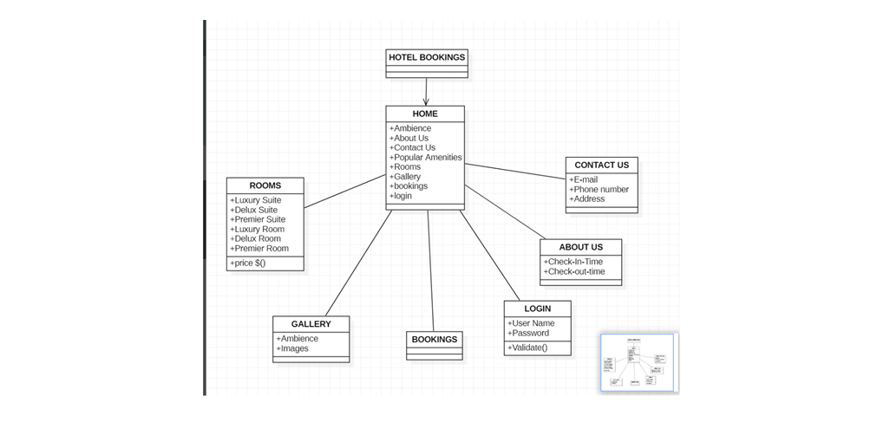

**Fig 6.1**

Use Case Diagram:

To model a system, the most important aspect is to capture the dynamic behavior. Dynamic behavior means the behavior of the system when it is running/operating.

The purpose of use case diagram is to capture the dynamic aspect of a system. However, this definition is too generic to describe the purpose, as other four diagrams (activity, sequence, collaboration, and State chart) also have the same purpose. We will look into some specific purpose, which will distinguish it from other four diagrams.

Use case diagrams are used to gather the requirements of a system including internal and external influences. These requirements are mostly design requirements. Hence, when a system is analyzed to gather its functionalities, use cases are prepared and actors are identified.

When the initial task is complete, use case diagrams are modeled to present the outside view.

In brief, the purposes of use case diagrams can be said to be as follows −

* Used to gather the requirements of a system.
* Used to get an outside view of a system.
* Identify the external and internal factors influencing the system.
* Show the interaction among the requirements is actors.

Figure below are the Use case Diagram for the current system:

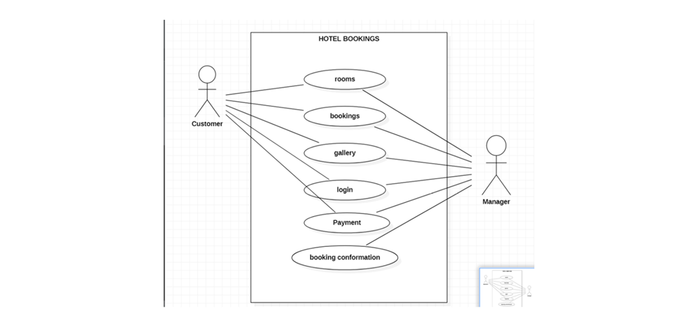

**Fig 6.2**

**CHAPTER – 7**

**MAINTENANCE**

The maintenance phase involves making changes to hardware, software, and documentation to support its operational effectiveness. It includes making changes to improve a system’s performance, correct problems, enhance security, or address user requirements. To ensure modifications do not disrupt operations or degrade a system’s performance or security, organizations should establish appropriate change management standards and procedures.

Routine changes are not as complex as major modifications and can usually be implemented in the normal course of business. Routine change controls should include procedures for requesting, evaluating, approving, testing, installing, and documenting website modifications. Maintaining accurate, up-to-date hardware and software inventories is a critical part of all change management processes. Management should carefully document all modifications to ensure accurate system inventories. Management should coordinate all technology related changes through an oversight committee and assign an appropriate party responsibility for administering software patch management programs. Quality assurance, security, audit, regulatory compliance, network, and end-user personnel should be appropriately included in change management processes. Risk and security review should be done whenever a system modification is implemented to ensure controls remain in place.

For maintenance of the website:

1. The database has to be updated regularly according to new available information.

2. Redundant and false information must be removed from the database.

**CHAPTER – 8**

**FUTURE SCOPE AND FUTURE ENHANCEMENT**

**PROJECT NAME: HOTEL BOOKING SYSTEM**

* Hotel Booking System will help you to book the rooms easily via our website and saves their time.
* It would provide huge details of every room with cost.

**CHAPTER – 9**

**CONCLUSION**

I have successfully implemented the site “HOTEL BOOKING SYSTEM”. With the help of various links and tools, I have been able to provide a site which will be live soon and running on the web. I have been successful in our attempt to take care of the needs of both the user as well as the administrator. Finally I hope that this will go a long way in popularizing.

**BIBLIOGRAPHY**

1. [www.javatutpoint.com](http://www.javatutpoint.com/)

2. [www.w3schools.com](http://www.w3schools.com/)

3. [www.getbootstrap.com](http://www.getbootstrap.com/)

4. [www.codeigniter.com](http://www.codeigniter.com/)

5. [www.stackoverflow.com](http://www.stackoverflow.com/)

6. [www.fontawesome.io](http://www.fontawesome.io/)

7. Learn HTML and CSS faster (Mark Myers)

8. Wikipedia

<https://github.com/harshitha047/PROJECT>